NTHM 099
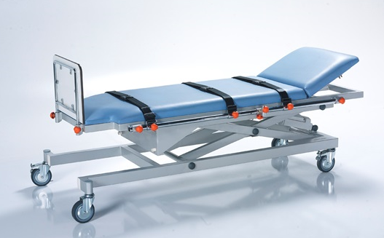
PATIENT EXAMINATION TABLE USER MANUAL
NITROCARE MOTORIZED PATIENT EXAMINATION TABLE

1. Introduction 2
2. PRODUCT DESCRIPTION 2
3. SAFETY AND WARNING 2
3.1. Safety and Warning Instructions 2
4. SYMBOLS AND LABELS ON THE PRODUCT 3
5. EXAMINATION TABLE GENERAL VIEW 4
6. AREA AND CONDITIONS OF USE 4
7. APPLIED STANDARDS AND REGULATIONS 5
8. SYMBOLS RELATED TO CONTROL TOOLS AND PERFORMANCE 5
8.1. Patient examination table Safe working load percentiles 6
9. Examination table transportation and installation 6
9.1. Transport 6
9.2. Installation 6
10. OPERATION 7
10.1. Initial start-up 7
11. ELECTRICAL SYSTEM AND CONTROL ELEMENTS 7
11.1 Electrical System 7
11.1.2 BRAKE SYSTEM 8
11.1.3 Cross Brake System 8
12. Movement Functions 8
13. Hand Control 9
14. Technical Dimensions 9
15. MAINTENANCE, REPAIR AND CLEANING INSTRUCTIONS 10
15.1. Maintenance and Repair Periods 10
15.1.1 Monthly Maintenance 10
15.1.2 Annual Maintenance 10
16. Cleaning / Disinfecting Instructions 10
16.1.1 Disinfect 11
17. Troubleshooting 11
18. SAFE STORAGE OF THE PATIENT EXAMINATION TABLE 12
19. ENVIRONMENT 12
20. WARRANTY 12
21. CONTACT 12

Login to
The use of motorized patient examination table used for adults, production design in line with standards and regulations, and the product is designed in line with the relevant technical information, and the examination table is produced in the desired performance without any risk during the use phase.

PRODUCT DESCRIPTION
NTHM 099 Models are designed for the patient to be used safely as an examination table, the height movement can be done with the help of the motor and the head movement can be done with the help of the shock absorber.

NTHM 099 Models are designed for maximum safety and mobility. Considering the patient's physical disabilities and comfort
The NTHM 099 models are designed to maximize the comfort of high-risk patients in every sense. Motorized
Hatsa inspection table is designed in accordance with TS 5541 standards. Thus, environmental environment, high performance
By minimizing the negativities against the dangers that may arise by providing risk assessment
Measures are being taken.

SAFETY AND WARNING

Safety and Warning Instructions

- Follow the instructions carefully and keep a copy of the instructions close to the stretcher if necessary.
- This user manual must be read before use to avoid customer damage and to obtain the best performance from the product.
- Make sure that the inspection table is used by a qualified person.
- Do not make any intervention while the examination table functions are in motion, it poses a danger due to limb entrapment of fingers, head, etc. through existing gaps.
- Lift the examination table max. 820 mm from the floor.
- Do not apply a load of more than 200 kg to the examination table.
- Only original spare parts and damaged parts should be replaced immediately and parts should be replaced by qualified personnel
- Do not overload the examination table beyond its carrying capacity.
- If you notice that the examination table does not fulfill its functions, do not use the examination table and inform the technical service.
- Inform the patient and other users about the functions of use.
- The examination table should be used indoors (observation rooms etc.)
- In case of any mechanical problems experienced on the examination table, intervention to the examination table should be carried out by trained personnel. When deemed necessary, the manufacturer's technical service unit should be informed and support should be obtained.
- During the delivery of the inspection table, training should be requested from the manufacturer for product use and intervention in case of any malfunction.
- Detailed technical information about the examination table should be requested if necessary.
- The safe operating weight must never be exceeded. If the safe weight must be exceeded, the surface on which the patient lies should be kept in its lowest position and the examination table functions should not be used.
- The second person should not sit on the examination table while the patient is lying down.
- To reduce the risk of injury from the patient falling off the examination table when left alone, the examination table should be lowered when it is at the top.
- The patient should not connect any other independent non-production mechanism to the examination table.
- In case of any malfunction, it should not intervene except authorized technical service.
- The examination table should never be used by more than one patient at the same time.
- When setting the examination table in the desired position, attention should be paid to the condition of the patient and the bed environment.
- Deliver the defective plastic etc. materials used in the examination table to the manufacturer or licensed waste company for environmental protection.
- Deliver the packaging materials such as cardboard, nylon, etc. used in product packaging to the licensed organization or manufacturer for environmental protection.
- The patient or caregiver is definitely in danger if
- During moving the examination table from one place to another when the floor and bed perimeter are unreliable.
- Improper maintenance
- When the safe working weight is exceeded.
- Only spare parts supplied by authorized service centers should be used. If spare parts from other suppliers are used, the examination table manufacturer assumes no responsibility for any damage, loss or injury.
- The emergency stretcher should be wiped with a damp cloth with a cleaning and disinfection solution of water at room temperature.

SYMBOLS AND LABELS ON THE PRODUCT
 | CE marking |  | Direction sign
 | Accompanying documents |  | Suitable for indoor use.
 | Read the user manual |  | General Warning Sign
 | Safe payload: 200 kg | 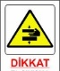 | Danger of handshake
 | Static Standing Load: 350 kg |  | Manufacturer
 |  |  | Company contact information, barcode number, product model, serial number, production date, label with medical device class

EXAMINATION TABLE OVERVIEW
4
1
2
3
1 | Footrest platform
2 | Tilt surface
3 | Seat belt
4 | Backrest platform
5 | Backrest platform movement lever
6 | Cross brake pedal
7 | Ø 125 wheels

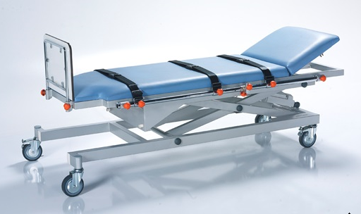
6
5
7

AREA AND CONDITIONS OF USE
Patient examination table; It is designed for the treatment of adults according to usage areas such as closed environments where medical interventions are performed in the hospital. Using the patient examination table outside of the instructions for use can cause serious injuries and poses a danger.


Use the patient examination table in areas deemed appropriate by the manufacturer and according to the purpose of production.

Use of the patient examination table may pose a hazard depending on temperature and humidity. Use the examination table in the following environments. Temperature Range -10°C to +40°C
- Relative humidity is between 30% and 75%.

APPLIED STANDARDS AND REGULATIONS
The patient examination table complies with the following standards and directives.
EU 2017/745 MDR replacing Directives 93/92 EEC
TS EN ISO 9001
TS EN ISO 13485
TS ISO 45001
TS ISO EN 14000
TS EN ISO 14971
TS 5541

SYMBOLS FOR CONTROL TOOLS AND PERFORMANCE

 | Downward function of the back section  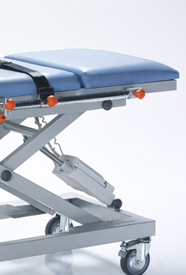 |  |  | Upward function of the back section  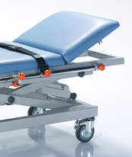
 | Downward straight position movement function  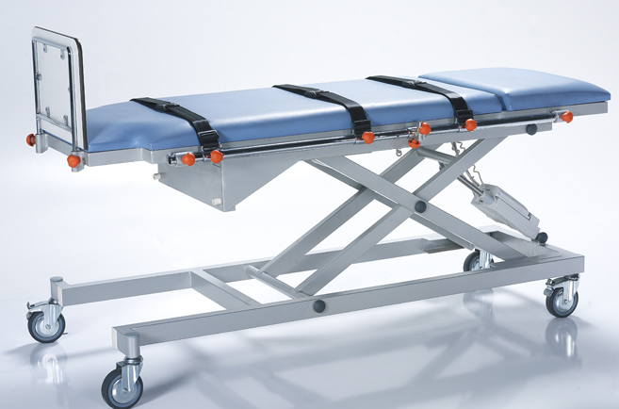 |  |  | Upward straight position movement function
 | Upright movement function to stand up  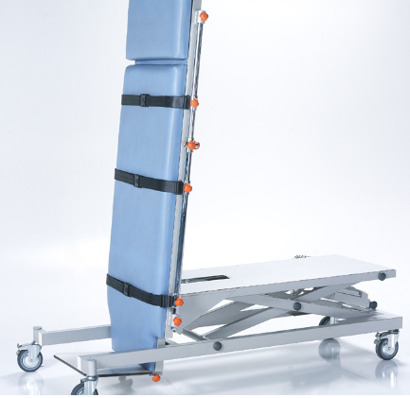 |  |  | Platform lowering flat position motion function  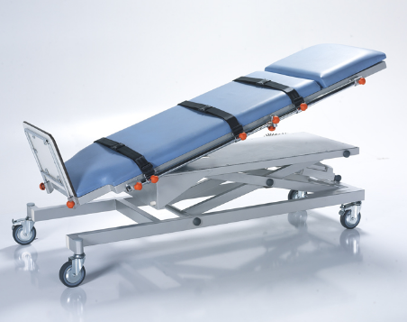,

Patient examination table Safe working load percentiles

A (VFM 45%)
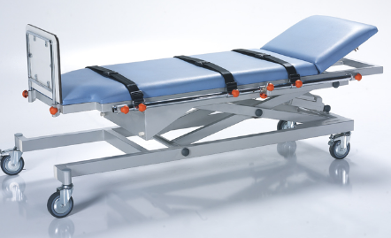
REGION | VALUE
A | 45% OF THE SAFE WORKING LOAD OF THE BACK SECTION
B | SEATING SECTION 35% OF THE SAFE WORKING LOAD
C | LEG SECTION 20% OF SAFE WORKING LOAD
GÇY | SAFE WORKING LOAD

B (VFM 35%)
C (GÇY 20%)

Examination table transportation and installation

Transport
Considerations for a safe transplant;
- transport the examination table on suitable surfaces.
- Make sure the patient is in the center of the examination table.
- Make sure that no cables are plugged in during the transfer process

Installation
Adjust the examination table as follows
- The following rules must be followed during the installation of the examination table.
- Please refer to the scope of delivery and inspection table variants.
- Attach the accessories accordingly.
- Make sure that the ground is suitable during installation.
- Deliver the dismantled packaging to the necessary places for environmental health.

NOTE: If any problem is encountered during the installation of the patient examination table, the intervention should be done by NİTROCARE technical service personnel.
CAUTION: Risk of injury
During assembly, install moving accessories last, as there is a risk of injury from falling.

CAUTION: Improper installation on the patient examination table may cause damage.
Patient examination table assembly should be done by technical service personnel or trained hospital staff

RUN

10.1. Initial Startup
Prepare the examination table as follows
-check the electrical connection points (socket inputs) before inserting the patient examination table plug into the socket.
-Check the connections of the grounding cables.
-Check the insulation of the connection cables. Check for any deformation or crushing.
-Plug the power cable into the socket for power. Make sure there is power
- start and check the height motors.
-Check the control controller.

11. ELECTRICAL SYSTEM AND CONTROL ELEMENTS

11.1 Electrical System
The patient examination table has a control box, a height motor and a hand control. As a working principle, the system consists of the control box receiving the data and performing the functions of the functions with the command process given from the hand control. Motor Below is the connection diagram of the system. Safety rules must be followed during connection. Read the instructions carefully in this regard. Read the electrical information on the product label.
The components and structure of NITROHB models are designed in accordance with safety rules.
The models have IPX4 / IPX6 degree of protection.
WARNING Electrical intervention should be carried out by authorized and trained personnel and support should be obtained from the manufacturer when necessary.
CAUTION: Do not touch the control box, motor and cables when performing the patient examination table function.
CAUTION: If the patient examination table is connected to an off-grid power supply, check the periodic checks of the power supply and refer to the instructions.
CAUTION: Electrical intervention must be carried out by trained personnel. Accidents due to electric shock may occur.

ELECTRICAL PROPERTIES
COMPONENT | MANUFACTURER / BRAND | TECHNICAL INFO
HEIGHT MOTOR | LINAK - DEWERT - POLİMOD | IMPORTED / 6000 N / DC / IPX4 / IPX6 24V / Max. 5.0 A
VERTICAL POSITION MOTOR | LINAK - DEWERT - POLİMOD | IMPORTAL / 8000 N / DC / IPX4 / IPX6 24V / Max. 5.0 A
CONTROL BOX | LINAK - DEWERT - POLİMOD | IMPORT /100-240 V ˜ / 50/60 Hz / Max. 5 A / IPX6
HAND CONTROL | LINAK - DEWERT - POLİMOD | IPX4  IPX6

11.1.2 BRAKE SYSTEM
The brake system is designed with cross brakes.

11.1.3 Cross Brake System

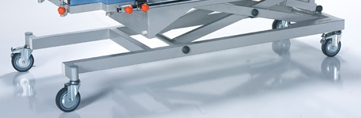

When the pedal on the patient examination table cross wheels is pressed downwards, the brakes become active and when the pedal is lifted upwards, the brakes become passive.

Movement Functions
The patient examination table makes the height and upright position movement with the help of the motor and the back angular movement manually with the help of the shock absorber.

CAUTION: risk of injury when performing the patient examination table movement function
Ensure that there are no body parts between the patient examination table platform.
When adjusting patient examination table positions, stay away from pinch points.
Do not move the patient examination table beyond the safe load.

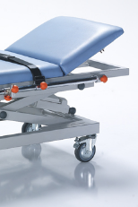 | Back Platform Down Movement  When you lift the orange lever upwards and apply a slight downward force on the platform, the back becomes flat. |  |  | Back Platform Up Movement  When you lift the orange lever in the upward direction, the backrest is in the up position.

Hand Controller
The examination table is designed for motion control. It is connected with flexible cable and can be easily used in the patient's position.
1.Bed platform provides upright position movement
2. The bed platform ensures straight position movement.
3.provides height movement upwards.
4.provides height movement downwards.
1
2
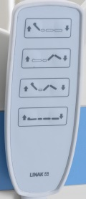
4
3

Technical Dimensions
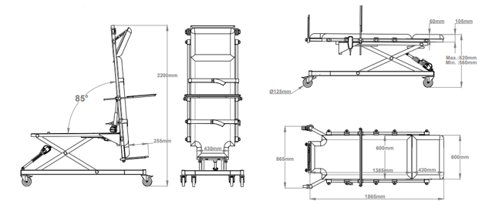

NTHM 099 MOTORIZED PATIENT EXAMINATION TABLE TECHNICAL SPECIFICATIONS
 |  |  | Measure | Unit
A | Patient examination table Length (Outside to Outside) |  | 1865 | mm
B | Patient examination table Width (Outside to Outside) |  | 865 | mm
C | Height of patient examination table | min. | 560 | mm
C | Height of patient examination table | max. | 820 | mm
α | Back Angle |  | 0-70 | °C
β | Straight Trendelenburg angle |  | 0-85 | °C
θ | Safe Load Capacity |  | 220 | Kg
 | Static Carrying Capacity |  | 350 | Kg
 | Wheel diameter |  | Ø125 | mm

MAINTENANCE, REPAIR AND CLEANING INSTRUCTIONS

15.1. Maintenance and Repair Periods

Injury may occur due to improper maintenance.
- The maintenance officer should seek support from the manufacturer in matters of which he/she is unsure.
- Take necessary safety precautions before maintenance.
- Do not use spare parts not recommended by the manufacturer.
- Do not perform maintenance while the examination table is in functional motion.


ATTENTION

NOTE: maintenance records should not be kept for each patient examination table and these should be done at regular intervals.

15.1.1 Monthly Maintenance
- Check the moving parts of the patient examination table (back, height)
- Check the joining elements (bolts, nuts, etc.)
- Check the accessory slots for any wear and tear.
- Check the wheels.

15.1.2 Annual Maintenance
- Check the joints of the movement functions.
- Check the joints of the patient examination table.
- Check the back shock absorber. Check the shock absorber connection bolts and function.
- Check the wheel function and check the wheel mounting bolts.
- Malfunctions caused by errors in use and spare part requests are not covered by the warranty.
- Maintenance should be carried out by trained hospital staff and if any problems are encountered, our company's technical service unit should be informed.
- Check all bolts and tighten if necessary
- Replace worn accessories
- Do not replace worn materials with faulty materials.


WARNING
Receiving spare parts requests and information

- NITROCARE technical service
- teknikservis@nitrocare.com.tr
- 0542 845 23 05

16. Cleaning / Disinfecting Instructions
16.1 Cleaning
- Use suitable detergents for cleaning. The VOC values of these detergents should be at appropriate values that will not harm the environment and people.
- Do not use abrasive powders, steel wool, steel wire brushes or abrasive sponges and cleaning agents that may damage product surfaces.
- Do not use detergents with solvents that can affect the structure and consistency of plastic (benzene, toluene, acetone, etc.)
- Clean the stainless steel areas of the product with maintenance spray, the pH value of the cleaning spray should be: 10.2.
- The density of the maintenance spray should be 0.855 g/cm³.
- Must be biodegradable.
- The cleaning spray must not contain AOX.

16.1.1 Disinfect
- The disinfectant Detrosept AF applied in the disinfection process must be a fast-acting alcohol-based spray and wipe disinfection product that does not contain phenol and aldehyde.
- Disinfecting use is applied by spraying to completely cover the pre-cleaned medical device (spray distance 30 cm). For its effectiveness, it should be kept for the duration of microbiological activity and the product should be wiped by choosing a sterile, non-particulate cloth.
- Properties of the disinfected product;
- Effective in 1 minute (bactericidal, fungicidal, virucidal, tuberculosidal)
- Aldehyde and phenol free
- Compatible with glass, ceramic, silicone, plastic (including plexiglass), wood, aluminum and stainless steel materials
- Broad spectrum of action
- 10% ethyl alcohol, 20% propane 2-ol, 0.25% Didesylmethylpoly(oxyethyl) ammonium propionate, preservative additives, perfume deionized water
- didecylmethylpoly (oxyethyl) ammonium propinate, protective
- Storage conditions of the disinfected product;
- The expiration date should be 2 years from the date of production.
- Keep the package tightly closed in a well-ventilated area between 0-25°.
Use disinfectants with special properties.
WARNING:
Disinfectant is flammable. Keep away from sources of ignition. Irritant Avoid contact with skin and mucous membranes. In case of contact with skin, rinse with plenty of water.

WARNING:
Do not spray directly on electrical devices. Take action after turning off the electricity.

Troubleshooting
PROBLEM | REASON | SOLUTION
BED ANY COMMAND  NO ANSWER: | - The plug is not plugged in  - The power cable is not working.  - The control box is not working.  - Hand Control Not Working | - Insert the plug into the socket.  - Replace the power cable.  - Send the control box for repair  - Send the hand control to service
ENGINE DOES NOT START WHEN THE SYSTEM IS RUNNING | - Engine malfunction  - Hand Control Malfunction | - The engine needs to be replaced, call the service.  - Send the hand control to service
THE ENGINE DOES NOT START WHEN THE SYSTEM IS RUNNING,  FROM THE CONTROL BOX '' CLICK ''' IF THERE IS NO SOUND: | - Control box defective  - The remote is defective | - Control Box needs to be replaced, call service  - The remote needs to be replaced, call the service.

SAFE STORAGE OF PATIENT EXAMINATION TABLE
To prevent damage to the patient examination table during storage;
- Pack the patient examination table so that there are no moving parts due to unintentional shaking.
- Keep patient examination table height to a minimum
- Adjust the patient examination table position so that it is level.
- Do not place the patient examination table under load during storage.

ENVIRONMENT
NITROCARE is committed to taking great steps to protect the environment with future generations in mind. The materials of this product are environmentally compatible. It does not contain hazardous substances. Symbols and signs should be paid attention to as information is provided with the symbols and signs used. The product uses recycled steel, electrical components, packaging materials, plastic materials.

- Return the packaging materials to the manufacturer or a licensed recycling company.
- Return the used defective plastic materials to the licensed recycling company or the manufacturer.

NOTE: For necessary information, please contact our after-sales service unit.



GUARANTEE
NITROCARE will only be held responsible for regular service and product reliability.
This product is covered by a 24-month warranty from the date of purchase. Defects caused by production and assembly defects are free of charge. Defects caused by usage errors are not covered by the warranty. Product use is determined within the framework of the terms and conditions determined by the standard.

CONTACT US
Organize Sanayi Bölgesi 1. Kısım 1.cad NO: 6 SİVAS/TÜRKİYE
Tel: 0346 218 19 10 Fax: 0346 218 19 14
E mail: info@nitrocare.com
http:// www.nitrocare.com
Satış Sonrası Hizmet İletişim
Tel : 0542 845 23 05
Mail : teknikservis@nitrocare.com.tr
Fax : 0346 218 19 14

