

NHB 4220 USER MANUAL



NHB 4220 Fiesta Series
4 MOTORS INTENSIVE CARE PATIENT BED LOWBED
®

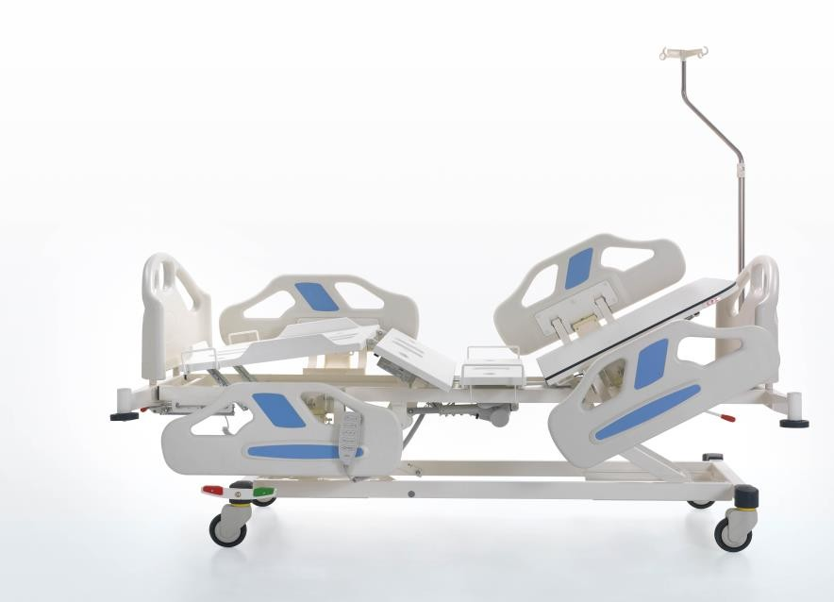

FR.KG. 33/00/05.08.2021

- INTRODUCTION 3
- PRODUCT DESCRIPTION 3
- SAFETY AND WARNING 3
  - Safety and Warning Instructions 3
- SYMBOLS AND LABELS ON THE PRODUCT Hata! Yer işareti tanımlanmamış.
- AREA AND CONDITIONS OF USE 7
- APPLIED STANDARDS AND REGULATIONS 7
  - Compliance with Standards 7
- Gap Distances Hata! Yer işareti tanımlanmamış.
  - Jamming Distances Hata! Yer işareti tanımlanmamış.
  - Foot Impingement Distance Hata! Yer işareti tanımlanmamış.
- Balance and Safe Working Load Hata! Yer işareti tanımlanmamış.
- Distance between Mattress and Side Railing Hata! Yer işareti tanımlanmamış.
  - Fall Protection Hata! Yer işareti tanımlanmamış.
- Side Railing Strength Hata! Yer işareti tanımlanmamış.
- Angular Movements Hata! Yer işareti tanımlanmamış.
- PATİENT BED DELIVERY AND INSTALLATION Hata! Yer işareti tanımlanmamış.
12.1 Transfer Hata! Yer işareti tanımlanmamış.
- Installation and Assembly Hata! Yer işareti tanımlanmamış.
- PATIENT TRANSPORTATION Hata! Yer işareti tanımlanmamış.
14.1 Considerations for Patient Transportation Hata! Yer işareti tanımlanmamış.
- OPERATION Hata! Yer işareti tanımlanmamış.
15.1 Initial Start-up Hata! Yer işareti tanımlanmamış.
- ELECTRICAL SYSTEM AND CONTROL ELEMENTS Hata! Yer işareti tanımlanmamış.
16.1 Electrical System Hata! Yer işareti tanımlanmamış.
- Movement Functions of the Patient Bed Hata! Yer işareti tanımlanmamış.
17.1 Hand Control Hata! Yer işareti tanımlanmamış.
- Manual Controlled Systems Hata! Yer işareti tanımlanmamış.
18.1 CPR Movement Hata! Yer işareti tanımlanmamış.
- Side Railing Hata! Yer işareti tanımlanmamış.
- Bedside and Footboard Panels Hata! Yer işareti tanımlanmamış.
- Brake System Hata! Yer işareti tanımlanmamış.
21.1 Central Brake System Hata! Yer işareti tanımlanmamış.
- Foot Platform Manual Angular Movement (Ratchet Movement) Hata! Yer işareti tanımlanmamış.
- Technical Dimensions Hata! Yer işareti tanımlanmamış.
- MAINTENANCE, REPAIR AND CLEANING INSTRUCTIONS Hata! Yer işareti tanımlanmamış.

24.1 Maintenance and Repair Periods Hata! Yer işareti tanımlanmamış.
- Monthly Maintenance Hata! Yer işareti tanımlanmamış.
25.1 Annual Maintenance Hata! Yer işareti tanımlanmamış.
- Spare Parts Hata! Yer işareti tanımlanmamış.
- Cleaning / Disinfecting Instructions Hata! Yer işareti tanımlanmamış.
27.1 Cleaning Hata! Yer işareti tanımlanmamış.
27.1.2 Disinfecting Hata! Yer işareti tanımlanmamış.
- TROUBLESHOOTING Hata! Yer işareti tanımlanmamış.
- SAFE STORAGE OF THE PATİENT BED Hata! Yer işareti tanımlanmamış.
- ENVIRONMENT Hata! Yer işareti tanımlanmamış.
30.1 Environmental Protection Hata! Yer işareti tanımlanmamış.
- WARRANTY Hata! Yer işareti tanımlanmamış.
- CONTACT Hata! Yer işareti tanımlanmamış.

INTRODUCTION
The use of the electric patient bed used for children (pediatric), cleaning, technical information, production design in line with standards and regulations, and the use of the product is not affected by any risk and product performance during the use of the product.

PRODUCT DESCRIPTION
NHB 4420P pedicatric Models is a pedicatric electric patient bed with 4 motorized back, foot, height and Trendelenburg movement functions designed for the safe treatment of the patient.

NITRO HB pediatric models are designed based on maximum safety and mobility. NITRO HB models, designed taking into account the physical disabilities and comfort of the patient, maximize the comfort of patients in the high-risk group in every sense.

Electric patient beds with NITRO HB pediatric model are designed in accordance with EN 60601-2-52 international standards. Thus, high performance is provided. The design has been realized by minimizing the negativities that may occur against the risks of the patient falling, squeezing, etc.

SAFETY AND WARNING


Safety and Warning Instructions
- Follow the instructions carefully and keep a copy of the instructions close to the bed if necessary.
- This user manual must be read before use to avoid customer damage and to obtain the best performance from the product.
- Use the correct mains supply for the pediatric cot
- Make sure that the cot is operated by a qualified person
- To eliminate the risk of electric shock, existing electrical medical equipment may only be connected to a supply network with protective earthing.
- The power supply cables pose a hazard due to entanglement, cutting or other mechanical damage due to improper handling.
- When the functions of the Pedıatrıc Patient bed are in motion, the cables may be pinched, so in case of sagging cables, do not perform any functionality on the bed by getting technical support.
- Do not interfere with the bed while the functions of the Pedıatrıc Patient bed are in motion, it poses a danger due to limb entrapment such as fingers, head, etc. through existing gaps.
- Do not use any other mattress other than the one used by the manufacturer. Dangers such as falling and jamming occur due to mattress dimensions.
- The distance between the top surface of the siderail and the top surface of the mattress should be at least 220mm when the siderail is locked.
- To prevent damage to the POWER SUPPLY CORD, wrap the POWER SUPPLY CORD around the cable winder mechanism that keeps the POWER SUPPLY CORD away from any moving parts or mechanisms of the PATİENT BED when the PATİENT BED is being used, transported or not in use.
- Raise the cot max. to a height of 780 mm from the floor.
- Do not apply a load of more than 150 kg to the Pedıatrıc Patient bed.
- Only original spare parts and damaged parts should be replaced immediately and parts should be replaced by qualified personnel

- Do not overload the bed beyond its carrying capacity.
- If you notice that the Pedıatrıc Cot does not fulfill its functions, do not use the cot and inform the technical service.
- Inform the patient and other users about the functions of use.
- Pediatric patient bed should be used indoors (wards, observation rooms, etc.)
- In case of any electrical and mechanical problems experienced in the Pedıatrıc Patient bed, the bed should be intervened by trained personnel. If necessary, the manufacturer's technical service unit should be informed and support should be obtained.
- Training should be requested from the manufacturer company for product use and intervention in case of any malfunction during the delivery of the Pedıatrıc Patient bed.
- Detailed technical information about Pedıatrıc Patient Bed should be requested when necessary.
- The safe operating weight must never be exceeded. If the safe weight must be exceeded, the surface on which the patient lies must be kept in its lowest position and the functions of the cot must not be used.
- The 2nd person should not sit while the patient is lying on the cot.
- When the patient is alone, the pediatrician should rise up when the cot is at the bottom to reduce the risk of injury from falling off the cot.
- The pediatrician should not connect any other non-production independent mechanism to the patient bed.
- In case of any malfunction, it should not intervene except authorized technical service.
- More than one patient should never use the Pediatric Cot at the same time.
- When adjusting the pedicab to the desired position, attention should be paid to the condition of the patient and the bed environment.
- Always unplug the power cord before cleaning or replacing any part of the cot.
- Please deliver the defective motor, plastic, etc. materials used in the Pedıatrıc Patient bed to the manufacturer or licensed waste company for environmental protection.
- Deliver the packaging materials such as cardboard, nylon, etc. used in product packaging to the licensed organization or manufacturer for environmental protection.
- The patient or caregiver is definitely in danger if
  - When the power cable is damaged
  - When moving the cot from one place to another when the floor and bed surroundings are unreliable.
  - Improper maintenance (e.g. automatic washing or washing with pressurized water)
  - When the safe working weight is exceeded.
- Only spare parts supplied by authorized service centers should be used. If spare parts from other suppliers are used, the bed frame manufacturer assumes no responsibility for any damage, loss or injury.
- Pediatric patient bed should be wiped with a damp cloth with a cleaning and disinfection solution with water at room temperature.

- ÜRÜN ÜZERİNDEKİ SEMBOLLER VE ETİKETLER
 | Protection against accidents due to electricity type B |  |  |  | Bed load: 220 kg
 | CE marking |  |  |  | IEC 60417-5019 / Earthing
 | Accompanying documents |  |  |  | Suitable for indoor use.
 | Read the user manual |  |  |  | General Warning Sign
 | Equipotentiality |  | CPR |  | CPR
 | Safe payload: 220 kg | 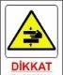 |  |  | Danger of hand entrapment
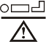 | Maximum patient load: 175 kg |  |  |  | Label used when removable parts exceed 20 kg
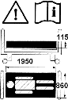   | Bed dimensional hazard, read the operating instructions, siderail functional hazard and caution symbols | 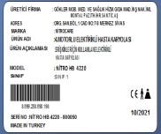 |  |  | Company contact information, barcode number, product model, serial number, production date, label with medical device class

WARNING If you see that any of the labels on the product is missing, please request it from the manufacturer.

3

4

1

2
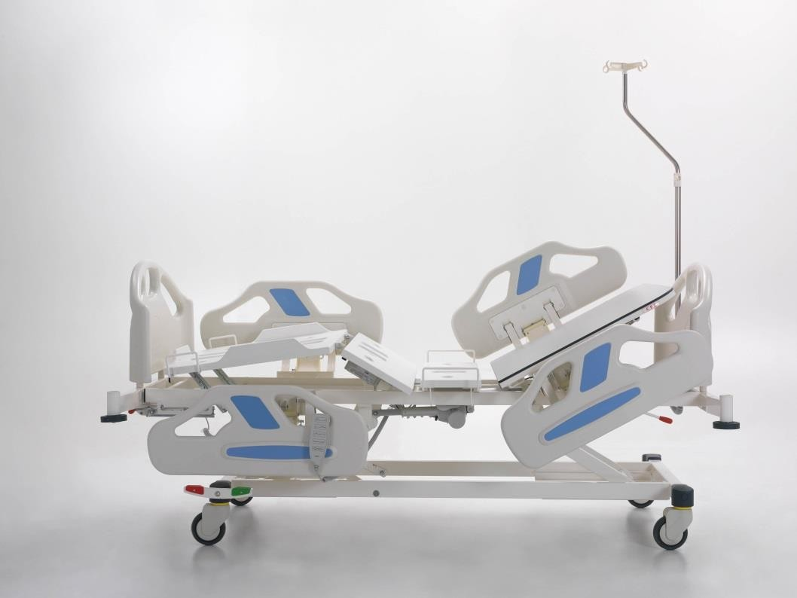

5
6
7

9

8

1 | Foot End Panel
2 | Side Railing
3 | IV Pole
4 | Bedside panel
5 | Impact protective bumper
6 | Mechanical CPR
7 | Ø125 Wheel
8 | hand control
9 | central brake

AREA AND CONDITIONS OF USE
Pedıatrıc Patient beds; It is designed for the treatment of children according to usage areas such as hospitals, homes and closed environments where medical interventions are performed. Using Pedıatrıc Patient beds outside of the instructions for use may cause serious injury and pose a danger.
The Pediatric Patient bed includes all parts of the patient bed accessible to the patient, even if the applied part is under the mattress support platform.

WARNING: Use the pedıatrıc Patient bed in areas approved by the manufacturer and according to its intended use.

The use of the Pedıatrıc Patient bed may pose a hazard depending on temperature and humidity. Use the cot in the following environments. Temperature Range -10°C to +40°C
- Relative humidity between 30% and 75
- The pediatric cot is intended for use in rooms for medical purposes. Electrical installations must therefore meet compliance with local connections.

APPLIED STANDARDS AND REGULATIONS
The patient bed complies with the following standards and directives.
- TS EN 60601-2-52, TS EN 60601-1,
- TS EN ISO 14971
- 93/42/EEC Replaced by MDR 2017/745 EU
- HORSE DECLARATION OF CONFORMITY

Compliance with Standards

Pedıatrıc Electric patient bed is manufactured in accordance with EN 60601-2-52 standards. In this direction, our patient bed, which we produce within the framework of international standards, keeps high performance, ergonomic and safety at the highest level.

Examples of patient entrapment in the patient bed and precautions taken accordingly;

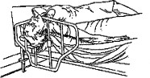 | 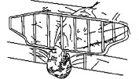 | 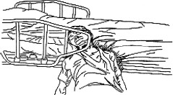 | 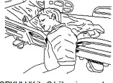 | 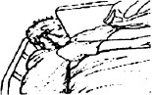 | 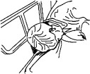

  - 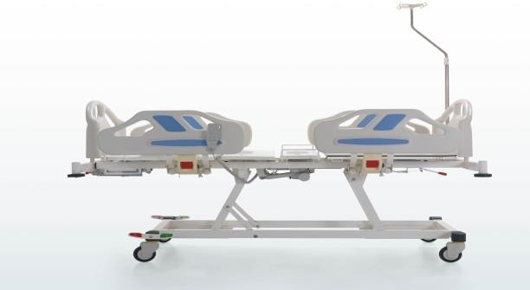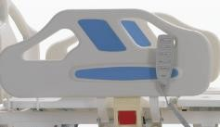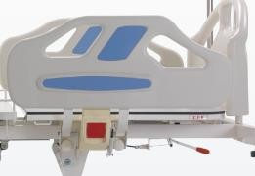Gap Distance
A
A
C
C
B
HEADREST
FOOTREST
A
B

PART | VALUE
A | ≤ 120 mm
B | ≤ 60 mm
C | ≤ 60mm Veya > 318 mm

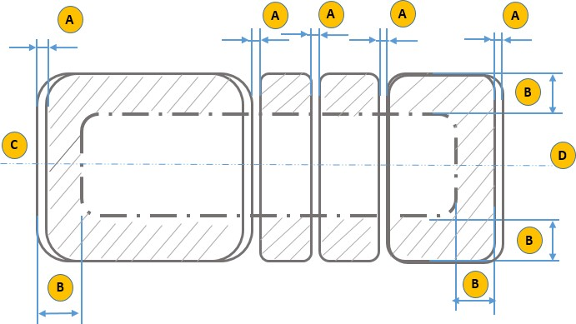
  - Impingement Distances
PART | VALUE
A | The gap between moving parts must be less than 8 mm (no gap) or more than 25 mm.
B | The hatched area represents the accessed impingement zone for the fingers 200 mm from the outer surface.
C | HEADREST PANEL
D | FOOTREST PANEL

  - Foot Entrapment Distance
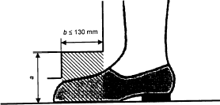
Description
For the zone where dimension "b" is less than or equal to 130 mm, dimension "a" is always greater than or equal to 120 mm.

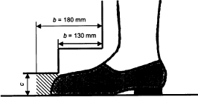
. .Description
For the zone where dimension "b" is between 130 mm and 180 mm, dimension "c" is always equal to or greater than 50
mm

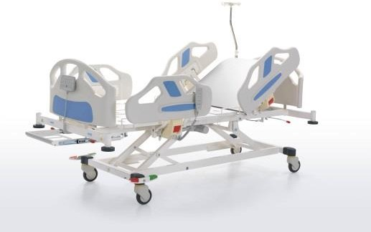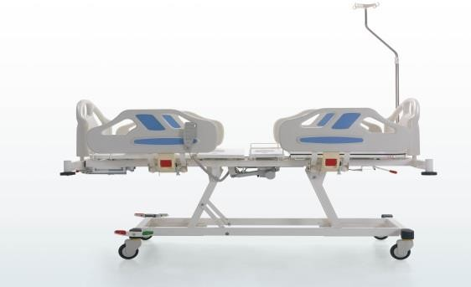
170 mm

1.1. Balance and Safe Operating Load
Static loads of 220 kg applied to the patient bed are applied to the areas required by the standard as shown in the figure below and the stability of the patient bed is tested.
Safe carrying capacity of the patient bed is 220 kg. Static carrying capacity is 440 kg.

220 kg
95 cm

25 cm
25 cm
220 kg

The SAFE OPERATING LOAD of the BED LIFT must be at least 2200 N. This load is considered as the sum of the following minimum loads.
1350 N, corresponding to a mass of approximately 135 kg for the PATIENT, 200 N, corresponding to a mass of approximately 20 kg for the mattress,
150 N, corresponding to a mass of approximately 15 kg for the SAFE OPERATING LOAD supported by these ACCESSORIES, excluding the ACCESSORIES and PATIENT mass. 500 N, corresponding to a mass of approximately 50 kg for those parts of the PATIENT BED designed to be lifted by the BED LIFT,

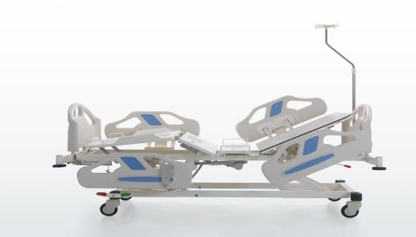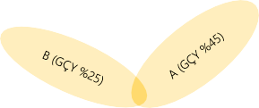
PART | VALUE
A | 45% OF THE SAFE OPERATING LOAD OF THE BACK SECTION
B | SEATING SECTION 25% OF THE SAFE OPERATING LOAD
C | LEG SECTION 30% OF SAFE OPERATING LOAD
GÇY | SAFE OPERATING LOAD

  - Distance between Mattress and Side Railing
Positive results are obtained when the distance between the mattress support platform and the side railing does not exceed 50% of the 120 mm-60 mm conical gauge.
A force of 250 N is applied to the 60 mm cylindrical end of the conical tool in the most unfavorable direction. The large end of the conical tool should not sink under the mattress surface by 50% or more than 120 mm diameter.
.

  - Fall Protection
Patient cot side rails and mattress top surface are designed with minimum height rules. In this way, the risk of the patient falling is minimized by making a risk assessment and the design is carried out in accordance with the standards.
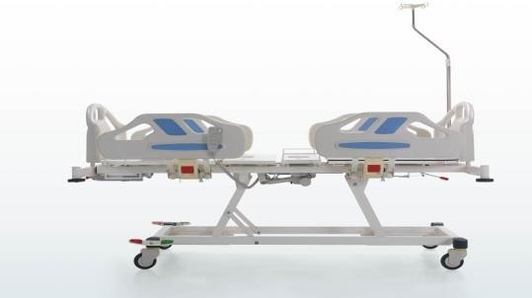
2
1
G
3
PART | VALUE
1 | HEAREST PANEL
2 | FOOTREST PANEL
3 | MATTRESS
G | ≥ 220 mm

  - Fall Protection
Forces are applied to the side rails in accordance with the EN 60601-2-52 standard..
C
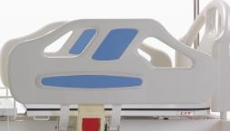
A
E
F
B
D
PART | VALUE
A | 500 N
B | 500 N
C | 750 N
D | 750 N
E | 500 N
F | 500 N

  - Angular Moves

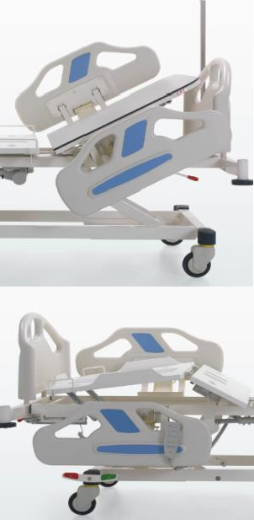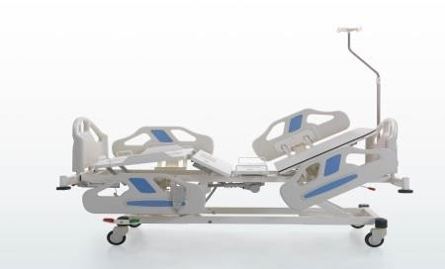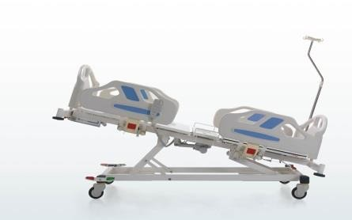
A
C
B
D
PART | ANGLE
A (Angle between the backrest and the level plane) | 0° - 70°
B (The joint point of the line drawn between the backrest section and the section/seating section where the lower part of the leg is placed and the section/seating section where the upper part of the leg is placed and the section/seating section where the lower part of the leg is placed. | Min 90°
C The angle B between the horizontal plane and the line drawn between the articulation point of the backrest/seating section and the articulation point of the upper leg section/lower leg section must be adjustable between at least 0° and 12°.
 | 0° -12°
D (Trendelenburg angle) | Min 12°

- SYMBOLS RELATED TO CONTROL TOOLS AND PERFORMANCER
 | Downward function of the back section  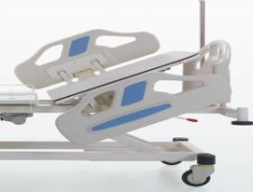 |  |  | Upward function of the back section  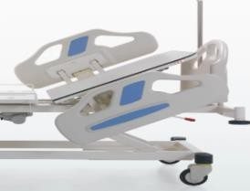
 | Upward function of the leg section  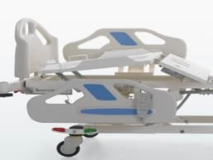 |  | 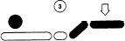 | Downward function of the leg section  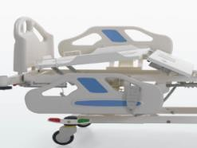
 | Trendelenburg  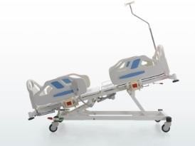 |  |  | Reverse Trendelenburg  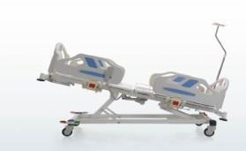
 | Straight down motion function  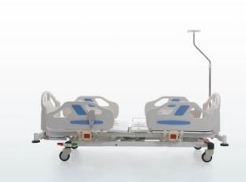 |  |  | Upward flat position motion function  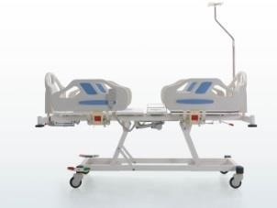

- PATIENT BED NECESSITY AND INSTALLATION
  - Transfer Considerations for a safe transfer;
- Make sure that no cables are connected during transport.
- Make sure that the power cable is wrapped around the hook on the bedside of the patient bed
- Make sure that the wheels are locked when loading and unloading
- Transport the bed on suitable ground.
- Check that the brakes are on during transportation.
- Remove accessories that may fall off during transfer.
Caution: Do not forget to unplug the power cord before transferring the patient bed.

  - Installation and Assembly Adjust the bed frame as follows
- The following rules must be observed when installing the bed frame.
- Refer to the scope of delivery and bed variants.
- Attach the accessories accordingly.
- Make sure that the floor is suitable during the assembly process.
- Make sure that the connection cables are plugged into the correct sockets.
- Check the earthing cables.
- Deliver the dismantled packaging to the necessary places for environmental health.

NOTE: If any problem is encountered during the installation of the patient bed, the intervention should be carried out by NITROCARE technical service personnel.
Caution: Risk of injury
During assembly, install moving accessories last, as there is a risk of injury from falling.
When assembling the electrical system, check the cables for any deformation of the cables, as there is a risk of electric shock. Ensure that the mains supply is disconnected when assembling the patient bed ensure that the castors are locked before assembly Installation of the patient bed must be done by technical service personnel or trained hospital personnel

- TRANSFER OF THE PATIENT
9.1 Considerations for Patient Transfer
Make sure that the patient bed is in the appropriate position.
- Make sure that no cables are connected during transport.
- Make sure that the power cable is wrapped around the hook on the bedside of the patient cot
- Make sure that the wheels are locked when loading and unloading
- Transport the bed on suitable ground.
- Check that the brakes are on during transfer.
- Remove accessories that may fall off during movement.
- Make sure that the patient is in the center of the bed.
- Make sure that the side rails are up.
- Make sure the cot is at the lowest level.

- OPERATION
  - First Operation Prepare the bed as follows;
  - Check the electrical connection points (socket inputs) before plugging in the bed.
    - Check the connections of the earthing cables.
    - Check the insulation of the connection cables. Check for any deformation or crushing.
    - Check the wheels and also check that the brake system wheels are functioning.
    - Plug the power cable into the socket for power. Make sure it is energized
    - Operate and check back, foot, height and other function motors.
    - Check the control controls and locks.
    - Check the function of the side rails.

- ELECTRICAL SYSTEM AND CONTROL ELEMENTS

11.1 Electrical System
The patient bed has a control box, foot motor, back motor, calf movement, height motor, hand control and nurse control. As a working principle, the system is formed by the control box receiving the data and performing the functions of the functions with the command process given from the hand control. Motors Below is the connection diagram of the system. Safety rules must be followed during connection. Read the instructions carefully in this regard. Read the electrical information on the product label.
The components and structure of the NITROHB models are designed in accordance with safety rules. The models have IPX4 / IPX6 degree of protection.
WARNING: Electrical intervention should be carried out by authorized and trained personnel and support should be obtained from the manufacturer when necessary.
CAUTION: Do not touch the control box, motor and cables while the patient cot is functioning.
CAUTION: If the patient cot is connected to an off-grid power supply, check the periodic checks of the power supply and refer to the instructions. CAUTION: Electrical intervention must be performed by trained personnel. Accidents may occur due to electric shock.

Wiring Diagram of the Electrical System
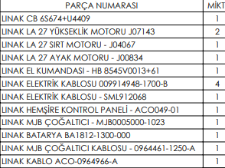
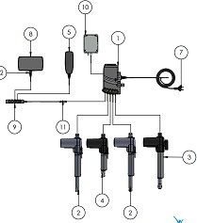

ELECTRICAL SPECIFICATIONS

COMPONENT | MANUFACTURER / BRAND | TECHNICAL INFO
FOOT MOTOR | LINAK – DEWERT - POLİMOD | IMPORTED / 6000 N / DC / IPX4 / IPX6/ 24V / Max. 5.0 A
BACK MOTOR | LINAK – DEWERT - POLİMOD | IMPORTED / 3500 N 4500 N / DC / IPX4 / IPX6/ 24 V / Max. 3.5 A
HEIGHT MOTORS (LIFTS) | LINAK – DEWERT - POLİMOD | IMPORTED / 2000 N / DC / IPX4 / IPX6 24V / Max. 5.0 A
CONTROL BOX | LINAK – DEWERT - POLİMOD | IMPORTED /100-240 V ˜ / 50/60 Hz / Max. 5 A / IPX6
HAND CONTROL | LINAK – DEWERT - POLİMOD | IPX4  IPX6
NURSE CONTROL REMOTE | LINAK – DEWERT - POLİMOD | IPX4  IPX6

  - Movement Functions of the Patient Bed
The patient bed performs back angular movement, foot angular movements, height and Trendelenburg movements with the help of an electric motor by giving a command from the hand control. In the foot section, the foot section is manually moved from the angular position to the parallel position by means of a 5-stage ratchet. The CPR arm on the patient bed again fulfills its function manually.
The side rails on the patient bed fulfill their functions manually with the help of the lock mechanism.

CAUTION: Dangers of injury when performing the movement function of the patient bed
Make sure that there are no body parts between the patient bed platform. When adjusting the position of the patient bed, stay away from pinch points. Do not move the patient bed beyond the safe load.
Model-dependent control elements;
- Hand control( Patient positions are adjusted)
- Nurse control panel (Patient positions are adjusted)
- Nurse control lock;
- Mechanical CPR

    - Hand Remote Control
The cot is designed for motion control. It is connected with a flexible cable and can be easily used by the caregiver and patient in any position.
Detailed function movements are given in Article 7.

- Manually Controlled Systems
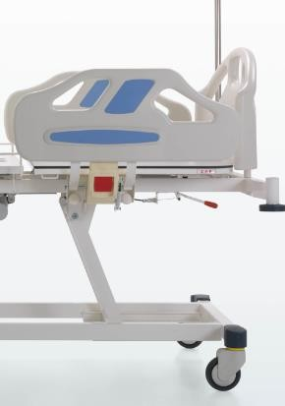12.1 CPR Movement

CPR, "CARDIOPULMONARY RESUSCITATION"
When the CPR handle is pulled, the back quickly becomes straight.
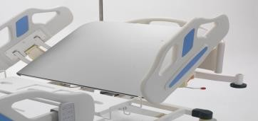 |  | 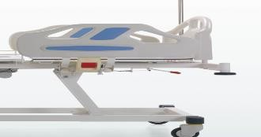

    - 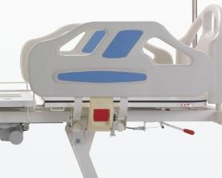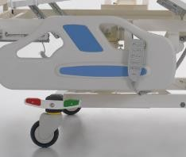Side Rail
When you pull the siderail lever outwards, the siderail functions downwards. WHEN THE SIDERAIL IS RAISED DIRECTLY UPWARDS, IT BECOMES CLOSED FUNCTION.

    - Bedside and Footboard Panels

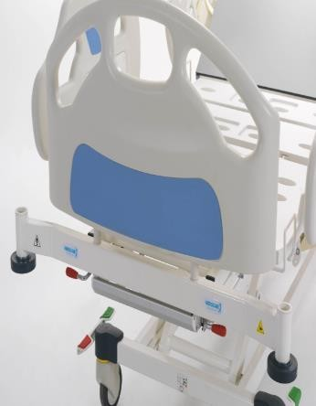 | Headboard and footrest platform can be easily removed and installed.  The cap on both sides of the headboard and footrest is removed by lifting up. In the assembly process, the head and footrests are placed in the slots.
 | 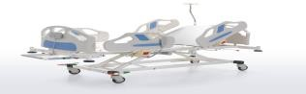 |  | 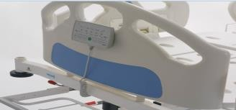

    - Brake System
It has a central braking system.

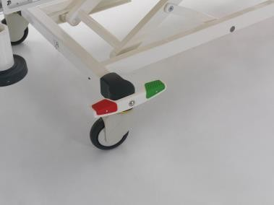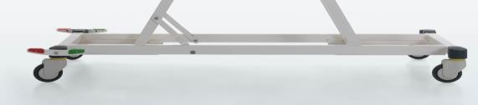11.3.5 Central Brake System
CENTRAL BRAKE IS USED IN THE PATIENT BED, WHEN THE BRAKE PEDAL IS PRESSED DOWNWARDS, THE BRAKES BECOME ACTIVE, WHEN THE PEDAL STOPS IN THE MIDDLE PART, THE WHEELS PROVIDE LINEAR MOVEMENT, WHEN THE PEDAL IS LIFTED UPWARDS, THE COT MOVES IN FREE POSITION.

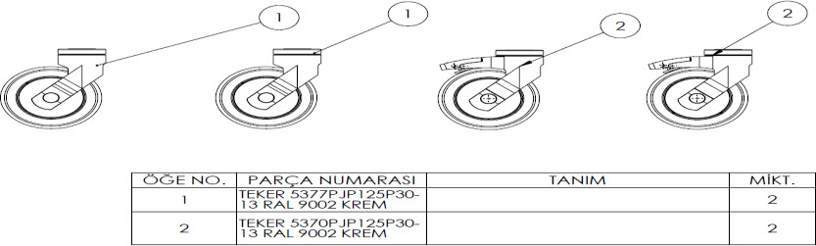

11.3.6. Foot Platform Angular Movement (Ratchet Movement)

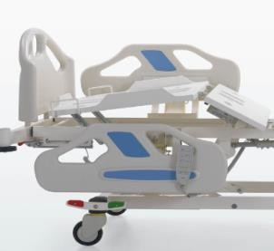 | 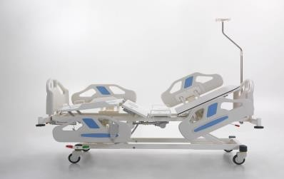
 | ANGULAR MOVEMENT OF THE FOOT PLATFORM IS REALIZED GRADUALLY WITH THE HELP OF THE CIRCIR. WHEN YOU LIFT THE PLATFORM UPWARDS, THE CIRCIR MOVES AND ANGULAR MOVEMENT OCCURS GRADUALLY. TO MOVE THE PLATFORM DOWN, THE CIRCIR IS MOVED TO THE TOP POSITION AND THEN THE PLATFORM IS RELEASED FREELY.

12. TECHNICAL DIMENSIONS

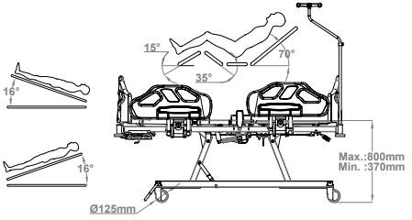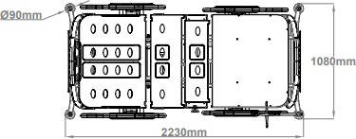
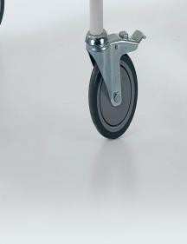
WHEELS
WHEELS ARE DIFFERENT AS OPTIONS. ( AS CENTRAL BRAKE AND CROSS BRAKE )

NITRO HB 4220 FOUR MOTOR BARIATRIC LIFT PATIENT BED TECHNICAL SPECIFICATIONS
 |  |  | Dimension | Unit
A | Bed Length (Outside Out) |  | 2230 | mm
B | Bed Surface Ground Height |  | Max. 800 – Min. 370 | mm
C | Bed Width (Outside Out) |  | 1080 | mm
D | Height of the IV holder | min. | 1100 | mm
D | Height of the IV holder | max. | 1250 | mm
α | Back Angle |  | 0-70 | °
β | Calf Angle |  | 0-35 | °
θ | Foot Angle |  | 0-15 | °
 | Safe Load Capacity |  | 220 | Kg
 | Static Carrying Capacity |  | 440 | Kg
 | Wheel Diameter |  | Ø125 | mm
 | Trendelenburg Angle |  | 16 | °
 | Mattress |  | 32 | d
 | Mattress dimensions |  | 860x1950x120 | mm

MAINTENANCE, REPAIR AND CLEANING INSTRUCTIONS
  - Maintenance and Repair Periods


Injury may occur due to improper maintenance.

The maintenance officer should seek support from the manufacturer company in matters he/she is not sure about.

CAUTION

Take necessary safety precautions before maintenance.

Do not use spare parts not recommended by the manufacturer.

Do not perform maintenance while the functional movement of the bed is being performed.

NOTE: Maintenance records should not be kept for each patient bed and should be done at regular intervals.

    - Monthly Maintenance

Check the moving parts of the bed (back, height, trendelenburg movement etc.)

- Check the joining elements (bolts, nuts, etc.)

Check the accessory slots for any wear and tear.
- Check the wheels and their functions.

Check the brake system.
- Check the side railing movement functions.

    - Annual Maintenance

Check the joints of the movement functions.
- Check the joints of the bed frame.

Check the bolts and joints of the brake system.
- Check the function of the hydraulic parts and check for any leakage or leakage.

Check the wheel function and check the wheel connection bolts.
- Check the siderail connection points and fasteners.
- Check the function of the brake lever.
Failures due to errors in use and spare parts demand are made outside the scope of warranty. Maintenance should be done by trained hospital personnel and if any problems are encountered,
our company's technical service unit should be informed. Check all bolts and tighten if necessary

UYARI
Replace worn accessories
Do not replace worn materials with faulty materials.

Receiving spare parts requests and information

CAUTION: Damage to the patient bed may result from improper care.
If the hospital authorized personnel are not sure, seek help from NITROCARE. Maintenance should only be carried out by authorized, trained personnel.

- Spare Parts
Failures due to errors in use and spare parts demand are out of the scope of warranty.
Maintenance should be carried out by trained hospital staff and if any problems are encountered, our company's technical service unit should be informed.
Receiving spare parts requests and information
  - NITROCARE technical service
  - teknikservis@nitrocare.com.tr
  - 0542 845 23 05
- .Cleaning / Disinfecting Instruction
  - Cleaning
  - - Use suitable detergents for cleaning. The VOC values of these detergents should be at appropriate values that will not harm the environment and people.
  - - Do not use abrasive powders, steel wool, steel wire brushes or abrasive sponges and cleaning agents that may damage the product surfaces.
  - - Do not use solvents and detergents that may affect the plastic structure and consistency (benzene, toluene, acetone, etc.).
  - - Clean the stainless steel areas of the product with a maintenance spray, the pH of the cleaning spray should be: 10.2.
  - - The density of the maintenance spray should be 0.855 g/cm³.
  - - It must be biodegradable.
  - - The cleaning spray must not contain AOX.
17.1.2. Disinfecting
  - - The disinfectant Detrosept AF applied in the disinfection process must be a fast-acting alcohol-based spray and wipe disinfection product that does not contain phenol and aldehyde.

  - - Disinfecting use is applied by spraying to completely cover the pre-cleaned medical device (spray distance 30 cm). For its effectiveness, it should be kept for the duration of microbiological activity and the product should be wiped by choosing a sterile, non-particulate cloth.
  - - Properties of the disinfecting product;

  - Effective in 1 minute (bactericidal, fungicidal, virucidal, tuberculosidal)
  - Aldehyde and phenol free
  - Compatible with glass, ceramic, silicone, plastic (including plexiglass), wood, aluminum and stainless steel materials
  - Broad spectrum of action
  - 10% ethyl alcohol, 20% propane 2-ol, 0.25% Didesylmethylpoly(oxyethyl) ammonium propionate, preservative additives, perfume deionized water
  - didecylmethylpoly (oxyethyl) ammonium propinate, protective
✓
  - - Storage conditions of the disinfected product;
  - The expiration date should be 2 years from the date of production.
Keep the package tightly closed in a well-ventilated and well-ventilated environment between 0-25°.
Use disinfectants with special properties.


UYARI: WARNING
Dezenfekte yanıcıdır. Tutuş turucu kaynaklardan uzak tutunuz. Tahriş edicidir Cilt ve mukoza Disinfectant is flammable. Keep away from sources of ignition. Irritant Avoid contact with skin and

hücrelerine temas ettirmeyiniz. Deri ile temasında bol miktarda su ile yıkayınız. mucous membranes. In case of contact with skin, rinse with plenty of water.

- TROUBLESHOOTING
PROBLEM | REASON | SOLUTION
BED DOES NOT RESPOND TO ANY COMMANDS: | - 1. It is not plugged in  - 2. The power cable is not working.  - 3. The control box is not working.  - 4. Hand control does not work | - Insert the plug into the socket.  - Replace the power cable.  - Send the control box for repair  - Send the hand control to service
ENGINE DOES NOT START WHEN SYSTEM IS RUNNING | - 1. Engine malfunction  - Hand Controller Malfunction | - The motor needs to be replaced, call service.  - Send the hand control to service
THE ENGINE DOES NOT START WHEN THE SYSTEM IS RUNNING, | - 1. Control box defective  - 2. The remote control is defective | - Control Box needs to be replaced, call service  - The remote needs to be replaced, call service.
FROM THE CONTROL BOX '' CLICK ''' IF THERE IS NO SOUND: | - 1. The battery is completely dead  - 2. Faulty battery | - Charge the battery  - Send the battery to service

BATTERY IS DEAD AND "DEAD IF THERE IS NO SOUND: | 1. 1. The battery is completely dead. | 2. Charge the battery, if the problem is not resolved, call service.
THE MOTORS DO NOT MOVE WHEN THE SYSTEM IS NOT PLUGGED IN: | 1. 1. The system needs to be RESET. | BY PRESSING THE BACK BUTTONS OF THE HAND CONTROL AT THE SAME TIME AND WAITING FOR 10 SECONDS, THE SYSTEM WILL BE ACTIVATED.  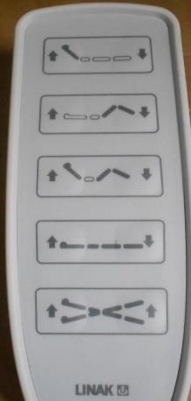

- SAFE STORAGE OF THE PATIENT BED

To prevent damage to the patient cot during storage;
Wrap the Power cable around the cable hook on the patient cot.
Remove the patient cot accessories and position them horizontally and properly on the cot. Pack the patient cot so that there are no moving parts due to unintentional shaking.
Keep the height of the patient cot to a minimum Adjust the patient cot position so that it is level. Set the brakes to the off position.
Do not leave the cot under load during storage.
Wrap electrical systems with protective packaging materials.

- ENVIRONMENT
  - Environmental Protection
NITROCARE is committed to taking great steps to protect the environment with future generations in mind. The materials of this product are environmentally compatible. It does not contain hazardous substances. Symbols and signs should be paid attention to as information is provided with the symbols and signs used. The product uses recycled steel, electrical components, packaging materials, plastics and wood materials.
The maximum acoustic noise level when the patient bed is in operation is 60 dB.
    - Defective electrical materials must be returned to the manufacturer without disposal.
    - Return the packaging materials to the manufacturer or licensed recycling company.
    - Return the used defective plastic materials to the licensed recycling company or the manufacturer.
NOTE: For necessary information, please contact our after-sales service unit.



- WARRANTY
NITROCARE will only be held responsible for regular service and product reliability.
This product is covered by a 24-month warranty from the date of purchase. Defects caused by manufacturing and assembly defects are free of charge. Malfunctions caused by errors in use are not covered by the warranty. Product use is determined by the terms and conditions set by the standard.

22 . CONTACT
Organize Sanayi Bölgesi 1. Kısım 1.cad NO:7-8 SİVAS/TÜRKİYE Phone: 0346 218 19 10 Fax: 0346 218 19 14
E mail: info@nitrocare.com http:// www.nitrocare.com
After Sales Service Contact
Phone : 0542 845 23 05
Mail : teknikservis@nitrocare.com.tr Fax : 0346 218 19 14

