GYNAECOLOGY DELIVERY BED

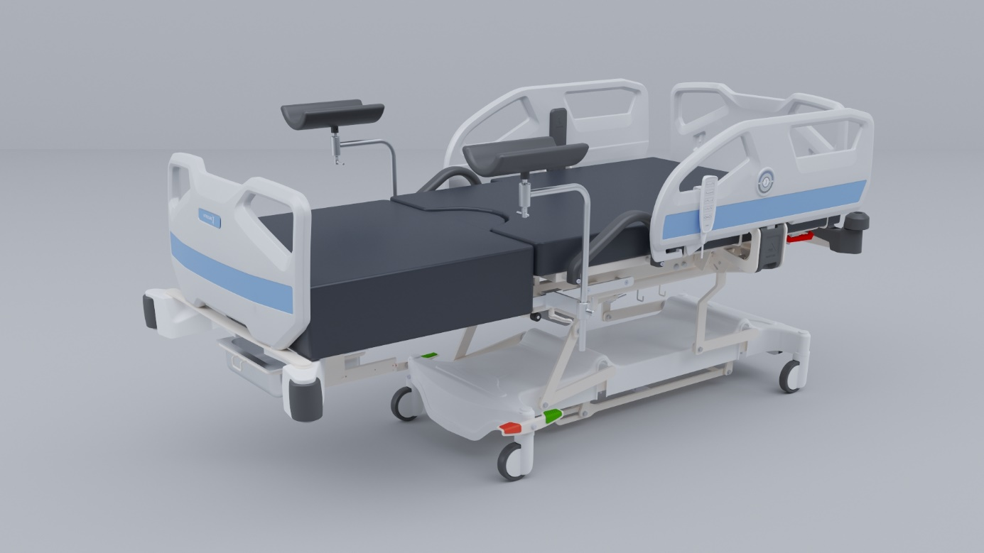

Nitrocare
Positionable
GYNAECOLOGY DELIVERY TABLE



Position Adjustable Patient Bed
Authorized Link: info@nitrocare.com

A) MANUFACTURER COMPANY : Gökler Mobilya Medikal ve Sağlık Hizmetleri A.Ş.
B) BRAND : NITROCARE
C) ADRES : Organize Sanayi Bölgesi 1. cad. No:7 Merkez / SİVAS
D) TEL NO : 0 346 218 19 10-13
E) FAX : 0 346 218 19 14
F) E-MAİL : info@nitrocare.com.tr
G) TYP : Hospital furnishings and equipment for medical purposes
H) MODEL : JMM 02
I) USEAGE LIFE : 10 Years
J) SERVICE STATION : Gökler Furniture Medical and Health Services Inc.

NITRO HB models are designed essentially with maximum safety and mobility. They are designed considering the physically disability and comfort for the highly risked patients.
This user manual must be read clearly through to avoid customer related damages and to achieve the best performance of the product.

1 Symbols 6
1.1 Warnings 6
1.2 Other Symbols 6
1.3 Symbols and Labels on the Product 7
1.3.1 Labels based on Control Devices and Performances 8
2 Security and Dangers 8
2.1 Security Instructions 9
2.2 Terms of Use 9
3 Standards and Regulations 10
4 Functions 10
4.1 Usage 10
4.2 Usage Error 10
5 Scope of Delivery of Patient Beds 11
5.1 Scope of Delivery 11
5.2 Bed Alternatives 11
6 Installation 11
6.1 Delivery 11
6.2 Carrying 11
7 Mounting 11
8 Operating 13
8.1 First Operating 13
8.2 Battery Operating 13
8.3 Take out of the Patient Bed from the Hospital Service 13
8.3.1 Battery Deactivating 14
9 Control Elements 14
9.1 Functions 14
9.2 Hand Control Panel 15
10 Systems with Manual Control 15
10.1 Head and Foot Boards 15
10.2 Backrest 16
10.3 Leg Support 17
10.4 Product Waste Bucket 17
10.5 Central Brake System 18
10.6 Foot Part 19
10.7 Holder 19
10.8 CPR Mechanism 20
11 PRODUCT LABEL INFORMATION 20
11.1 Product Control Card 20
11.2 Product Confirmation Label 21
12 Cleaning / Disinfection 22
12.1 Periodical Cleaning 23
12.1.1 Daily Cleaning 23
12.1.2 Cleaning before patient changing 23
13 Problem Solving 23
14 Maintenance and Repair 24
14.1 Maintenance Periods 25
14.1.1 Monthly Maintenance 25
14.1.2 Maintenance in every 4 months 25
14.1.3 Maintenance in every 12 months 25
14.2 Spare Part 25
14.2.1 Corrosion 25
14.2.2 Functionality 26
14.2.3 Motors 26
14.2.4 Battary 26
14.2.5 Fuses 26
14.2.6 Castors 26
14.3 Accessory 26
15 Safety Controls 26
16 Disposal 27
16.1 Environment Protection 27
17 Warranty 27
18 EC Declaration of Conformity 28
19 Technical Details 31
19.1 Accuracy of Displayed Values 31
19.2 Mechanical Specifications 31
19.3 Electrical Specifications 32
20 Storage 33
21 Product Delivery 34
22 Service and Maintenance Diary 35

1. Symbols
1.1 Warnings
1.1.1 Warning Types

Recognize the kind of danger by using the symbols below in warning announcements.
- Warning, it shows property potential damage.
- Warning to personal injury risks.
- Warning to danger potential fatal injuries.

1.1.2 Warning Structure

Danger type and source:
- Danger precautionary warnings

1.3 Symbols and Labels on the Products
 | B Type safety due to electricity accidents
 | CE Symbol
 | Accompanying Documents
 | Read user manual
 | Safe carrying weight
 | Maximum weight of the patient
 | Grounding
 | Suitable to indoor use
 | Patient bed is cleanable with moist cleaning rag
 | Jammer danger
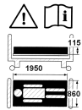 | Bed dimensional occurring danger, Read the user manual, Side rail operating danger and warning symbols
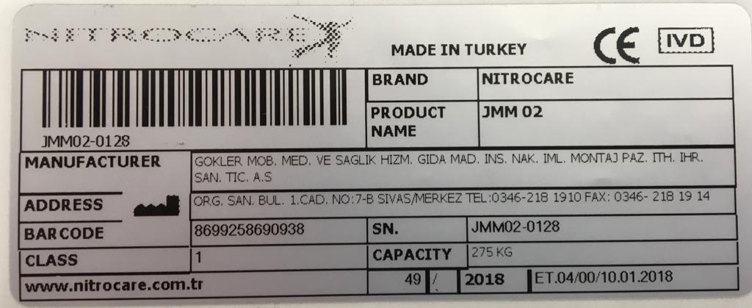 | Product label
1.3.1 Labels based on Control Devices and Performances

2. Security and Dangers
2.1 Security Instructions
- Please follow the instructions clearly and place a copy of the instructions near to the bed if it is required.
- Use the right power supply for the bed
- Please be sure that a qualified staff operates the bed
- Spare parts can be changed only with the original one. It must be changed from qualified staff.
- Please do not load to many weight on beds
- Please do not use the bed when you notice that the functions do not work and inform the technical department.
- Pass information to the patient and other users regarding the functions.
- Do not exceed safe carrying capacity. In case of exceeding this capacity, lower the height of the bed to the lowest position in horizontal straight form and do not use the functions of the bed.
- A second person is not allowed to sit on the bed while a patient is laying on it.
- Patient bed shall not be used from more than one person at the same time.
- Please control the safety of the floor and the environment of the bed before adjusting the position if.
- Plug out the power cable before cleaning the bed or before changing any parts of it.
- Patient and the nurse are in danger at the situations listed below.
- When the power cable is damaged.
- When the floor and the ambiance around the bed is not save while transporting the bed from one place to another.
- By wrong cleaning ,( example; automatic cleaning or cleaning with pressure water)
- When the safe weight capacity is exceeded.
- Only spare parts from the authorized service can be used. Manufacturer cannot be held responsible for any damage, loss or injury by using separate parts from other suppliers.
- Cleaning must be done with room temperature water and disinfect solution with a moist cleaning rag.
2.2 Terms of Use
Terms of use of patient bed must be followed
- Temperature range must be between +10 ° C and 40 ° C
- Bound moisture is between 30 % and 75 %
- Beds are designed for use of medical purpose for rooms. Electrical installations must therefore suit with the local connection.
- Conditions listed below must be followed.
- Do not stow something on the plastic bottom chassis
- Back leaning section:0-80⁰ Max:85⁰
- Trendelenburg min:14,5⁰ - 5⁰
- Do not connect the patient bed with another free mechanism.
Only the technical service is allowed to treat in any breakdown situation
3. Standards and Regulations
Patient bed suits to the standards and directives listed below.
TS EN 60601-2-52 : 2011
TS EN 60601-1 : 2011
TS EN ISO 14971: 2013
93/42/EEC
90/384/EEC
Application of quality management system is listed below.
ISO 9001: 2000
ISO 1400: 2004
TS EN 13485: 2003
TS EN 17025: 2014
4. Functions
4.1 Usage
Gynecology and delivery Table are designed for patient care and treatment of adults in hospitals. It is suitable for use as a gynecology and Delivery table.
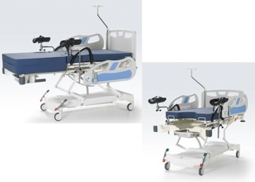
Gynecology and Delivery Table must be controlled from qualified and trained staff.

4.2 Usage Error
Gynecology and Delivery are not applicable for children and babies.
- Do not use the bed without supervision of qualified staff

P.S.: Do not use the bed except the usage mentioned above. For required information contact NITROCARE.

5. Scope of Delivery of Patient Beds
5.1 Scope of Delivery
Delivery:
- Please control the products by receiving the delivery if they are delivered exactly to the packing slip.
- By noticing some defects or losses of the product during the unloading, please inform the technical service in written form.
- Please test all mechanical and electronic functions and be sure that all motors and all control buttons are working as required.
5.2 Bed Alternatives
S= standard
İ= optional
Customer required bed specifications
- Castors
- Tente integral single castors 150 mm
- Control equipment
- Control Panel
6. Installation

6.1 Delivery
Points to consider for safe transportation
- Be sure that no cables are connected while transport
- Be sure that the electrical cable is connected to the hook which is placed at the head of the patient bed
- Be sure that the castors are locked while loading and unloading
- Carry all beds on proper floors
6.2 Carrying
Do the adjustment listed below
- Follow the rules listed below during the installation of the beds
- Lock at the scope of the delivery and bed alternatives
- Assemble all accessories to their right slots
- Assemble the foot and head boards while delivery
- Be sure that the floors are suitable for mounting

7. Mounting
WARNING

Working at a bed with wounding risks Be sure that the patient bed is plugged out while mounting Be sure that the castors are locked before mounting Montaj öncesinde tekerlerin kilitli olduğundan emin olun

Wrong mounting of the patient bed can injure Mounting off the patient bed must be don from the technical service or from a trained hospital staff.

NITROCARE Patient bed general specifications
1. Head Board 7. Arm Handle
2. Hand Control Panel 8. Central Brake System
3. Side Rails open close (lock) 9. Product waste tub
4. Plastic Protaction Bumpers 10. Putting Legs
5. CPR Handle 11. Side Rails
6. 125mm Castors 12. IV Pole

8. Operating
8.1 First Operating
Prepare the bed as listed below;
- Plug in the bed
- Adjust the bed to the highest position and try literal movements
- Adjust the bed to the lowest position and try literal movements
- Control the castors and the brake system if they are working well.
- Try fowler and vascular positions and control if the motors are working well.
- Control the control panel and lock panel.
- Control the functions of the side rails.
- Send the removed packing to the essential places for environmental health.
P.S: If some problems occur by assembling, please contact the NITROCARE technical service and let them interfere to the problem.
8.2 Battery operating
Patient beds are delivered with battery. Battery is for further working process when power is cut and when any adjustment is require while transport of the bed.
Battery charging:
- Battery is charging when power cable is plugged in.
- Battery is charging when power cable is plugged in.
Battery mounting
Battery changement must be done from qualified and trained staff.

WARNING

To optimize the battery performance:
- By power cut and by patient transport, plug out the power cable for a short time.
In case of heat at the battery place
- Plug out the cable of the patient bed.
- Contact NITROCARE technical service.
8.3 Take out of the patient bed from the hospital service
Patient bed must be taken out as listed below.
- Plug out the cable of the patient bed.
- Deactivate the battery
- Take out the accessories

To store the patient bed without harming;
- Patient bed and accessories together must be packed properly.
Storing must be done proper and suitable to the working conditions of the patient bed.
8.3.1 Battery deactivating
Make provision to not damage the environment of the patient bed while storing
- Deactivate the battery
To deactivate the battery:
- Brake the power connection of the patient bed
9. Control Elements
9.1 Functions

Wounding risks by adjusting the patient bed
Be careful to not jam in the body of the patient between the bad platform and back rest.
Stand apart from the adjusting parts of the patient bed by adjusting the positions.
Do not move the patient bed by passed safe carrying capacity.

WARNING

Control elements connected at the model
- Control Panel (To adjust the position of the patient)
- Control Panel with LED (To adjust the position of the patient)
- Nurse Control Panel ( To adjust the position of the patient)
- Nurse Control Lock
All positions are out of use by locking the nurse control lock.

9.2 Hand Control Panel
It is connected by a flexible cable and can be easily used by the Nurse and the patient in any position. Provides ease of use with LED illumination.

Connected by flexible cable, it is possible for the user to use it easily in any position
• 1/2 Backrest Movement up / down
• 3/4 Height Lift / Lower (Examination table position remains constant when height adjustment is performed)
10. System with Manual Control
10.1 Head Board Part
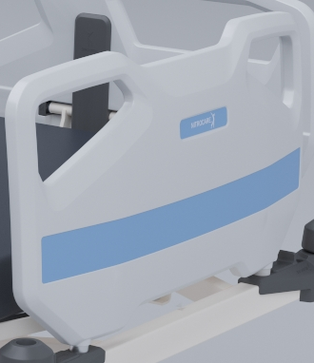
There are 2 Boards on the product.
Boards can be pulled upwards and removed.

10.2 Backrest
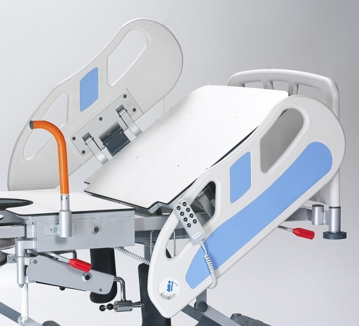
-It is the area used on the flat platform prior to the patient's intervention, where it is necessary to lie down or tilt. During the intervention, the back can be lifted and the patient can be brought back to the flat position after the intervention if the patient needs to sleep.
-The back part has an angle of 80 degrees to the front and can be adjusted at the desired Angle.
- Be careful not to pinch fingers during at the forward movement.
- Be careful not to pinch fingers during at the backward movement.
- The backrest should be checked before the patient is admitted.
- The operation of the motor must be checked before the patient lays down.
- The backrest has a carrying capacity of 70 kg, which is also the case when the backrest is raised.
- Keep the controls locked when the backrest is open.
- Do not use the backpart as a loading surface.
- Do not squeeze any liquid or water to clean any internal components, as this may cause short circuit or corrosion.

10.3 Legs Support

- There are 2 Legs Holder on the product, each Leg Holder has a carrying capacity of 30 kg. For overweight (obese) patients please consult the manufacturer.
- The part shown in Figure 1 is to be intervened with the leg part of the product together with the leg support.
- Figure 2 shows the side view of the product without leaving the foot part.
- The part shown in Figure 3 is an image of the ability of the leg-bearing section to be hidden under the bed.
- In figure 4, pushing the button indicated by the arrow is pulled up with the legs carrying the scissors. The picked up apparatus is brought to the upright position. As shown in figure 5, the use is ready.
- The compression mechanism shown in Figure 7 provides the compression of the foot mechanism in the determined position. The placement of the foot can be compressed at the desired angle and position according to the shape of the bed.
- The Figure shown at 8 is the adjustment-compression mechanism of the leg-resting apparatus, which allows the leg to be stopped at the desired height or at the desired level.

10.4 Product Waste Bucket

- The product tub is designed to accommodate the wastes that may be generated during in the intervention.
- The Bucket It is in a position where it can be easily taken out.
- The Bucket is made from stainless steel and does not contain dirt or rust.
- Since the Bucket is made of stainless steel, there is no hygiene problem and the product can be cleaned.
- Please do not use acid products during the washing.
- It can be washed and disinfected with acid-free cleaning products.

10.5 Central Brake System
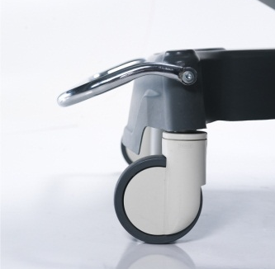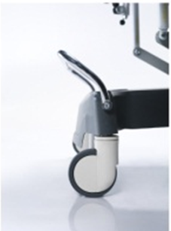
- When the pedal is depressed slightly in the wheel lock mechanism, all wheels are locked to prevent the bed from moving.
- When we raise the pedal slightly up and into the empty position, all the wheels are released.
- When pushing up the pedal with a slight force, the anti-static directional circuit enters.

IMPORTANT NOTE :
Do not use parts produced by different manufacturers other than all the components that make up the engine, cable, control, product on the gynecological Bed. This is necessary to prevent malfunction. Different manufacturers' adapters will not be able to adapt to fit the product, the patient and the user will be damaged. The equipment must only be serviced and repaired by authorized service personnel for safe and reliable operation for maintenance, repair and installation. If the maintenance and repair team can not intervene, you should contact the technical service to get remote assistance. Certainly do not call outside the company.

10.6 Foot Part
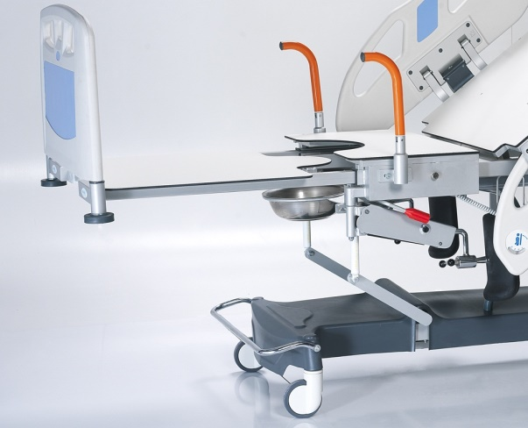
There are 2 Legs Holder on the product, each Leg Holder has a carrying capacity of 30 kg. For overweight (obese) patients please consult the manufacturer.
10.7 Holder

- There are 2 holders on the product, designed to hold the patient easily in case he needs to lift himself.
- As shown in Fig. 2, the grips are pulled upwards and lowered vertically.
- When you want to open the handle, lift it up.
- Designed with the psychological state of the patients to get up without help.
- Do not use water, cleaning agent in the play part when cleaning the handle.
- In case of difficult movement of the moving part, should be used Products like be vaseline for provide easy movement of metal.
- The handle can be kept closed when not in use.
10.8 CPR Mechanism

CPR is designed to allow the head part to reach zero position (parallel to the plane) from maximum position in an emergency.
The arrow shown in the figure is drawn in the direction of the arrow and the back part is held for a maximum of 5 seconds

11. PRODUCT LABEL INFORMATION

NITROCARE company's product contains information about the product.

11.1 Product Control Card

- The product control card covers the last control before the product left the factory.
- All items on the last control card are checked before the product is approved for release, after confirming that there are no missing points, the product output is confirmed.
- The final control card is intended to prevent accidental or incomplete product formation due to intentional misconduct.
- The items on the last control card are marked as "applicable" or "not applicable", if the item is not applicable on the subject, marked "not applicable" for this product.

11.2 Product Confirmation Label

• The product approval label is a label that allows all controlled items to leave the factory.
• It is not possible to leave the factory without a product approval label.
• The date and signature are included on the label.
P.S.: Please check if you have received the gynecologic Bed;
- Check all bed linen for any damage.
- Check the equipments.
- Check power cord and plug.
- Check whether it is operating by pressing the botton from the hand control.
- Check the motors.
- Check the brake system to turn on and off.
-Check that the backrest section is moving with the aid of the motor.
- Control the forward and backward movement of the head part.
- If you see the section that is not working as a result of the checks, please inform the authorized service agent without any intervention.

12. Cleaning / Disinfection
Accidentaly wounding risk
Plug out the power cable before cleaning the bed.
Lock the adjustment functions before cleaning the adjustable parts of the patient bed.
.

WARNING

Wrong cleaning/disinfection which can damage the bed
Do not use pressure cleaner. Do never use for cleaning acid, solver, detergent, phosphate or phosphate consisting or corrosive products (8 - optimum pH between 6).

WARNING

P.S: Headboard plastics, handle plastics and other plastics used at the patient bed are made of antibacterial plastics (ABS). Metal surfaces are covered with electrostatic powder coating. All Nitrocare Products are therefore easy cleanable. Patient beds can be cleaned with moist cleaning rags or sponges. Important matter by cleaning is to clean the total surface and the control panels of the patient bed after the release of the patient.

For safety and healthy cleaning
- Plug out the power cable of the patient bed.
- Use a suitable detergent for cleaning.
- Do not use abrasive powders, steel wool or other harming materials and cleaning materials.
- Do not use solver and detergents which can affect the plastic structure and stability (benzene, toluene, acetone aso.)
- Clean the bed with a proper squeezed moist cleaning rag.
- Do not clean the electrical parts.

12.1 Periodical Cleaning
12.1.1 Daily Cleaning
Clean the bed parts listed below
- All control panels
- All side rails/ handles
- CRP handle
- Bed surface and head/foot boards
- Accessories and rails

12.1.2 Cleaning before patient changing
Clean the bed parts listed below
- All control panels
- All side rails/ handles
- CRP handle
- Easy accessible bed surface
- Mattress platform surface
- Easy accessible metal surface
- Cables
- Side Rails
- Bumpers
- Brakes
- Castors
- All accessories
- Lifts
13. Problem Solving
Problem | Reason | Solution
Gynecology bed do not follow any commands : | - Is the connector plugged in.  - Electrical cable does not work.  - Control case does not work | - Plug the connector in.  - Change the electrical cable.  - Send the control case to service.
When the motors do not work while the system is on or,  A ‘click’ noise comes out of the control case: | - The socket connection between the motor and the control case is not connected.  - Motor is broken  - Control case is broken | - Control that the socket connection between the motor and the control case is connected.  - Call the service to change the motor.  - Call the service to change the control case.
When the motors do not work while the system is on or,  A ‘click’ noise does not come out of the control case: | - Control case is broken  - Control panel is broken | - Call the service to change the control case.  - Call the service to change the control panel.
When the battery is empty and a ‘click’ noise is not to hear: | - Battery is totally empty  - Battery has a defect | - Load the battery.  - Change the battery.
When the motors does not work while the system is plugged in: | Battery is totally empty. | Load the battery. If this do not solve the problem call the service.
System does not work | System requires a reset. | Press at the back rest up and down adjustment buttons at the same time and wait till the kick sound starts and stops. When the sound stops, system will be again active.

Power failure
When you are confronted with a power failure, please let only the authorized person solving this problem.

14. Maintenance and Repair
14.1 Maintenance Periods
Accidentaly wounding risk
Plug out the power cable before cleaning the bed.
Lock the brakes while mounting and maintenance.

WARNING


WARNING

Defective beds can have wounding risks
Defective beds must be immediately repaired. It is strictly forbidden to use defective beds.

WARNING
Patient bad can injure because of wrong maintenance.
Please get help from NITROCARE when the authorized person is not sure about the handlings.
Maintenance shall only be made from authorized and trained person.

P.S: A registration must be held for maintenance of each patient bed and it must be done periodically.

14.1.1 Monthly Maintenance
Control all movable parts for corrosion.
14.1.2 Maintenance in every 4 months
Control the handle of the brake function.
Do the function controls from the lifts.
Control the screws and hinges of the patient bed.
Control the movable mechanism of the patient bed.
Control the screws on the castors and if required tighten the screws.
Control the movement and the reliability of the side rails.
14.1.3 Maintenance in every 12 months
General controls of the mechanical movement systems and plastic accessories of the patient bed must be done. All wearing parts and loosening parts must be changed after this procedure.
14.2 Spare Part
- Spare parts demand regarding wrong use is not covered by the guarantee.
- Maintenance shall only be made from authorized and trained person. Inform the technical service from NITROCARE by any problems.
Spare part and information demands
- NITROCARE technical service
- teknikservis@nitrocare.com.tr
- 0542 845 23 05
14.2.1 Corrosion
- Control the screws on the castors and if required tighten the screws.
- Control all lock mechanisms.
- Change all worn accessories.
- Do not use wrong parts after changing wearing accessories.
14.2.2 Functionality
- Control the position adjustment of the patient beds that they are functioning with maximum efficiency.
- Change all worn parts.
14.2.3 Motors
- Control the motor adjustments.
- Control the wrong and broken adjustments. Change the faulty motor if necessary.
- Control the motor caps, change the caps if they are worn.
14.2.4 Battery
- Control that the battery is working properly. (Plug out the power cable of the patient bed)
- Change the battery in required circumstances.
14.2.5 Fuses
Changing and controls of the fuses must be done from experienced and trained personal.
Fuses can only be changed from the manufacturer. (LINAK)
    - Castors
- Clean the castors completely.
- Control the connection screws and change it if necessary.
- Move the castors and control that they are functioning properly.
- Forwards and backwards movement.
- Limitless movement.
- Control the brake system and change it if necessary.
14.3 Accessories
- Control the accessories and be sure that they are functioning properly and change it if necessary.
15. Safety Controls
Wrong safety controls can have wounding risks.
Safety providing will be done from our technical servis of our factory. Safety controls will be noted in the product delivery, technical service and after sales service form.

WARNING
Defective bed can have wounding risks.
Defective beds must be immediately repaired.

Do not continue using beds with big damage.

WARNING

P.S: Patient beds are manufactured suitable to TS EN 16601-2-52 / TS EN ISO 14971 standards. All required tests and examination controls are done under supervision of TSE auditors. This will be reported to maintain the quality of the products.

16. Disposal
16.1 Environment Protection
NITROCARE cares about the environmental protection for the posterity and makes great strides in this opinion.
Materials of this product have environmental compatibility. It does not contain dangerous substances.
Customer will be informed with the used symbols and signs.
Recycling steel, electrical components and wooden parts are used in the manufacturing.
Products are packed with recyclable boxes.



17. Warranty
NITROCARE can only be held responsible for its regularly service and product reliability.
When a critical irreparable problem rises while maintenance
Stop using the patient bed.
This product has a warranty period of 24 months from the date of purchasing. Defects arising from manufacturing and installation will be repaired free of charge. Defects arising from wrong use are not covered by the guarantee. Product using terms and conditions are indicated from standards.

18. EC Declaration of Conformity

19. Technical Details
19.1 Accuracy of Displayed Values
- Weight (integrated scales)
0.5 kg
- Angle of inclination
± 3 ͦ
19.2 Mechanical Specifications
TRENDELENBURG / REVERSE TRENDELELBURG | TREND BY MOTORS ( 14,5 º ). REVERSE TREND WITH MOTOR. ( 5 º )
METAL STRUCTURE | THICKNESS FOR BOX PROFILE : 1,2 - 2,00 mm. FOR PIPE 1,2 - 2,00 mm
BOTTOM FRAME SIZE | 40 x 60 x 2 mm
UPPER FRAME SIZE | 50 x 30 x 2 mm / 30 x 20 x 2 mm
SIZES (BUMPER TO BUMPER) | W : 1070 mm ; L : 2320 mm
HEIGHT | MIN : 605 mm, MAX : 875 mm
SAFETY PATIENT CAPACITY | 275 KG
BACK ANGLE | 0-80°

19.3 Electrical Details
Parts and construction of NITRO HB models are designed pursuant to general safety rules.
These models have IPX4 degree of protection.
Device Specification
 | Manufacturer | GÖKLER A.Ş.
 | Brand | NITROCARE
 | Input Voltage | 230v
 | Voltage Tolerance | ±10%
 | Frequency | 50 Hz
 | Power | 340 VA
 | Output Voltage | 24 V Permanent
 | Class | 1
 | Type | B
 | Protection Degree | IPXX,

MOTOR SPECIFICATIONS
 | Hight Adjustment Motor | Back rest Adjustment Motor | Leg Rest Adjustment Motor
Manufacturer | LINAK  DEWERT  ILCON | LINAK  DEWERT  ILCON | LINAK  DEWERT  ILCON
Components | Manufacturer/Brand | Technical Details
MOTOR 1 | LINAK  DEWERT  ILCON | IMPORTED / 3500 N / DC / IPX4  IMPORTED / 2000 N/DC /IP66 IMPORTED / 4000 N/DC /IPX6
MOTOR 2 | LINAK,DEWERT,ILCON | IMPORTED / 3500 N / DC/IPX4  IMPORTED / 4000 N/DC /IP66 IMPORTED / 4000 N/DC/IPX6
MOTOR 3 | LINAK,DEWERT,ILCON | NOT
MOTOR 4 | LINAK,DEWERT,ILCON | NOT
Control Case | LINAK,DEWERT,ILCON | 230 V, 50Hz
Hand Control Panel | LINAK,DEWERT,ILCON | --
Control Panel Lock Kit | LINAK,DEWERT,ILCON | --

20. Storage
To store beds long time, the instructions listed below must be followed
  - Reset all settings of the bed
  - Please be sure that the castors are set on a smooth floor.
  - Please do not stow another bed on it or another heavy product

21. Product Delivery
Order number :

Client :

Model number :

Serial number :

Delivery Date :

Delivered From :

Confirm form the hospital personal that the delivered patient bed is working properly.

Date :

Seal and Signature form the Client:

Seal and Signature from the Carrier :

22. Service and Maintenance Diary

Service Explanation | Date | Operated From

Contact:
Address: Organize Sanayi Bölgesi 1. Kısım 1.cad NO:7 SİVAS/Turkey
Telephone: 0346 218 19 10
Fax: 0346 218 19 14
E-Mail : info@nitrocare.com
Website: http:// www.nitrocare.com

