HB 7410 MIRANDA COMFORT - USER MANUEL

NITROCARE ELECTRIC PROFILING FLOOR BED


HB 7410 SERIES®

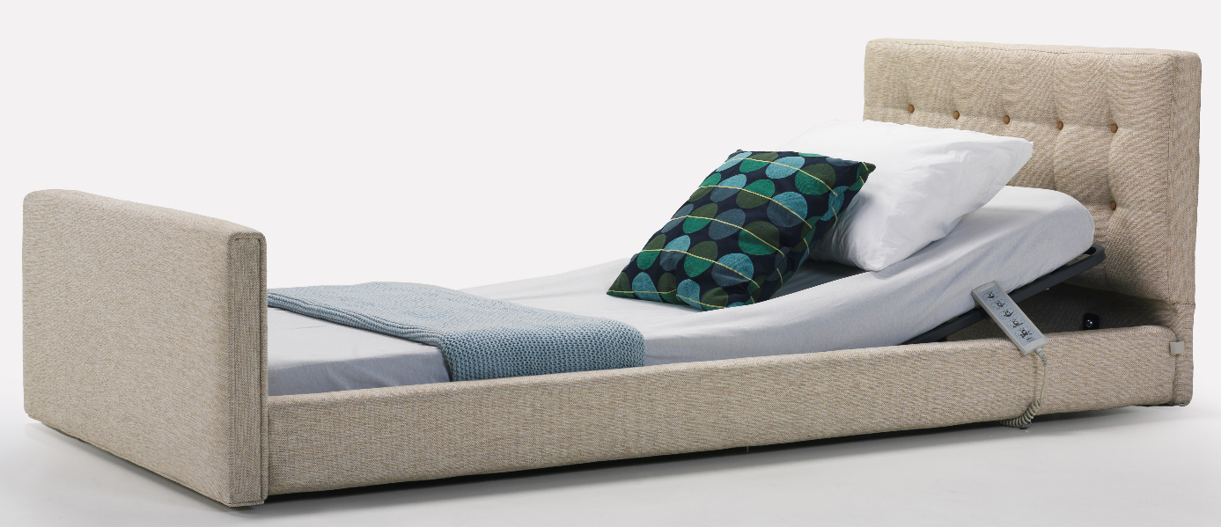

Table of Contents
1. Introduction 3
2. PRODUCT DESCRIPTION 3
3. SAFETY AND WARNING 3
3.1. Safety and Warning Instructions 3
4. SYMBOLS AND LABELS ON THE PRODUCT 4
5. AREA AND CONDITIONS OF USE 5
6. APPLIED STANDARDS AND REGULATIONS 5
6.1. Compliance with Standards 5
6.2. Compression Distances 6
6.3. Foot Impingement Distance 6
6.4. Balance and Safe Working Load 6
6.5. Distance between Mattress and Side Railing 7
6.6. Fall Protection 7
6.7. Side Railing Strength 7
8. THE PURPOSE AND INSTALLATION OF THE PATIENT BED 8
8.1. Transfer 8
8.2. Installation and Assembly 8
9. TRANSPORTING THE PATIENT 8
9.1 Considerations for Patient Transportation 8
10. OPERATING 9
10.1. Initial Startup 9
11. ELECTRICAL SYSTEM AND CONTROL ELEMENTS 9
11.1 Electrical System 9
12. TECHNICAL DIMENSIONS 10
MAINTENANCE, REPAIR AND CLEANING INSTRUCTIONS 10
13.Maintenance and Repair Periods 10
13.1 Monthly Maintenance 10
13.2 Annual Maintenance 11
14. Spare Parts 11
15. Cleaning / Disinfecting Instruction 11
15.1 Cleaning 11
15.2. Disinfect 11
16. TROUBLESHOOTING 12
17. SAFE STORAGE OF THE PATIENT BED 12
18. ENVIRONMENT 12
18.1 Environmental Protection 12
19. GUARANTEE 13
20. COMMUNICATION 13

1. INTRODUCTION
The use of the electric patient bed used for adults, cleaning, technical information, production design in line with standards and regulations, and the use of the product is not affected by any risk and product performance.
2. PRODUCT DESCRIPTION
NHB 7410 Models are electric patient beds with motorized back, foot, height and Trendelenburg movement functions designed for safe treatment of the patient.
NITRO HB Models are designed based on maximum safety and mobility. Designed taking into account the physical disabilities and comfort of the patient, NITRO HB models maximize the comfort of patients in the high risk group in every sense.
Electric patient beds with NITRO HB Model are designed in accordance with international standards. Thus, high performance is provided. The patient's fall, jamming, etc. The design has been realized by minimizing the negativities that may occur against risks.
3. SAFETY AND WARNING

3.1. Safety and Warning Instructions

• Follow the instructions carefully and keep a copy of the instructions close to the bed if necessary.
• These operating instructions must be read before use to avoid customer damage and to obtain the best performance from the product.
• Use the correct mains supply for the bed
• Ensure that the bed is operated by qualified personnel
• To eliminate the risk of electric shock, existing electrical medical equipment may only be connected to a power supply network with protective earthing.
• If the power supply cables are not handled properly, there is a risk of tangling, cutting or other mechanical damage.
• When the patient bed functions are in motion, the cables may become pinched, so do not perform any functions on the bed by seeking technical assistance if the cables become dangling.
• Do not interfere with the bed while the patient bed functions are in motion, it poses a danger due to finger, head, etc. limb entrapment through existing gaps.
• Do not use any other mattress other than the 860x1950x12 mm 32 density mattress used by the manufacturer. Dangers such as falling and pinching occur due to mattress dimensions.
• The distance between the top surface of the siderail and the top surface of the mattress should be at least 220mm when the siderail is locked.

• To prevent damage to the POWER SUPPLY CORD, wrap the POWER SUPPLY CORD around the cable winder mechanism that keeps the POWER SUPPLY CORD away from any moving parts or mechanisms of the PATIENT BED when the PATIENT BED is being used, transported or not in use.
• Do not apply more than 220 kg load to the patient bed.
• Only original spare parts and damaged parts should be replaced immediately and parts should be replaced by qualified personnel.
• Do not overload the bed beyond its carrying capacity.
• Do not use the bed and notify the technical service if you notice that the bed does not fulfill its functions.
• Inform the patient and other users about the functions of use.
• The patient bed must be used indoors (wards, observation rooms, etc.).
• In case of any electrical and mechanical problems in the patient bed, the bed should be intervened by trained personnel. When deemed necessary, the manufacturer's technical service unit should be informed and support should be obtained.
• During the delivery of the patient bed, training should be requested from the manufacturer for product use and intervention in case of any malfunction.
• Detailed technical information about the patient bed should be requested when deemed necessary.
• The safe operating weight must never be exceeded. If the safe weight must be exceeded, the surface on which the patient lies must be kept in its lowest position and the functions of the bed must not be used.
• A second person must not sit on the bed while the patient is lying down.
• To reduce the risk of injury from falling off the bed when the patient is alone, the bed should be raised when it is at its lowest position.
• The patient should not connect any other non-production independent mechanism to the bed.
• In case of any malfunction, it should not intervene except authorized technical service.
• More than one patient should never use the bed at the same time.
• When adjusting the bed in the desired position, attention should be paid to the condition of the patient and the bed environment.
• Always unplug the power cord before cleaning or replacing any part of the bed.
• Deliver the defective motor, plastic, etc. materials used in the patient bed to the manufacturer or licensed waste company for environmental protection.
• Deliver the cardboard, nylon, etc. packaging materials used in product packaging to the licensed organization or manufacturer for environmental protection.
• The patient or caregiver is definitely in danger in the following situations.
- When the power cable is damaged
- When moving the bed from one place to another when the floor and bed surroundings are unreliable.
- Improper maintenance (e.g. automatic washing or washing with pressurized water)
- When the safe operating weight is exceeded.
• Only use spare parts supplied by an authorized service center. If spare parts from other suppliers are used, the bed manufacturer does not accept any responsibility for any damage, loss or injury.
• The patient bed should be wiped with a damp cloth with a cleaning and disinfecting solution of water at room temperature.
4. SYMBOLS AND LABELS ON THE PRODUCT

 | Protection against accidents due to electricity type B |  | Bed load 220 kg
 | CE marking |  | IEC 60417-5019 / Earthing
 | Accompanying documents |  | Suitable for indoor use.
 | Read the user manual |  | General Warning Sign
 | Equipotentiality | CPR | CPR
 | Safe payload: 220 kg | 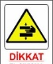 | Danger of handshake
 | Maximum patient load: 200 kg |  | Label used when removable parts exceed 20 kg
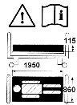   | Bed dimensional hazard, read the operating instructions, siderail functional hazard and caution symbols | 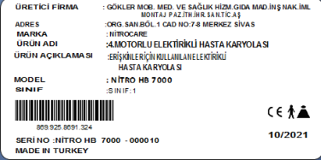 | Company contact information, barcode number, product model, serial number, production date, label with medical device class


If you see that any of the labels on the product is missing, please request it from the manufacturer.

5. AREA AND CONDITIONS OF USE
Patient beds; It is designed for the treatment of adults according to usage areas such as hospitals, homes and closed environments where medical interventions are performed. Using patient beds outside of the instructions for use may cause serious injury and pose a danger.
The patient bed includes all parts of the patient bed that are accessible to the patient, even if the part to which the patient bed is applied is under the mattress support platform.
Use the patient bed in areas deemed appropriate by the manufacturer and
according to its intended use.

Use of the patient bed may pose a hazard depending on temperature and humidity. Use the bed in the following environments. Temperature Range must be between -10°C and +40°C
Relative humidity between 30% and 75
The bed is intended for use inside rooms for medical purposes. Electrical installations must therefore meet compliance with local connections.
6. APPLIED STANDARDS AND REGULATIONS
The patient bed complies with the following standards and directives.
- TS EN ISO 14971
- TS EN 60601-2-52
- 93/42/EEC Replaced by MDR 2017/745 EU
- DECLARATION OF CONFORMITY
6.1. Compliance with Standards
Our patient bed, which we produce within the framework of international standards, keeps high performance, ergonomic and safety at the highest level.
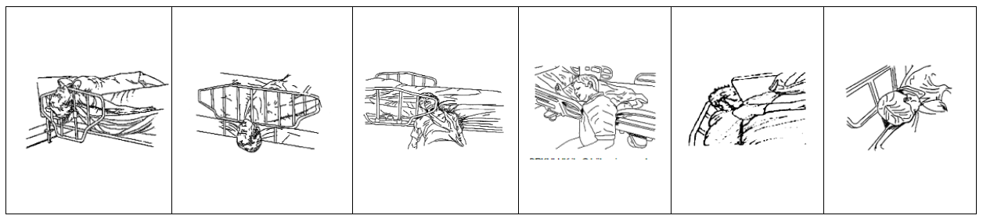
Examples of patient entrapment in the patient bed and the measures taken in this direction;

AREA | VALUE
A | The gap between moving parts must be less than 8 mm (no gap) or more than 25 mm.
B | The hatched area represents the accessed impingement zone for the fingers 200 mm from the outer surface.
C | BED HEAD PANEL
D | FOOT HEAD PANEL
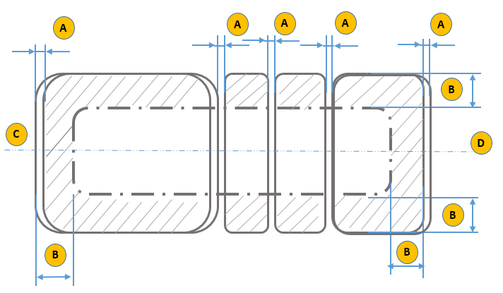
6.2. Compression Distances

6.3. Foot Impingement Distance
Description
For the zone where dimension “b” is less than or equal to 130 mm, dimension “a” is always greater than or equal to 120 mm.

Description
For the zone where dimension “b” is between 130 mm and 180 mm, dimension “c” is always greater than or equal to 50 mm.

6.4. Balance and Safe Working Load
Static loads of 220 kg applied to the patient bed are applied to the areas required by the standard as shown in the figure below and the stability of the patient bed is tested.
Safe carrying capacity of the patient bed is 220 kg.
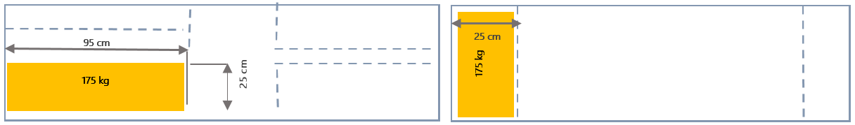
Static carrying capacity is 350 kg.

6.5. Distance between Mattress and Side Railing
Positive results are obtained when the distance between the mattress support platform and the side railing does not exceed 50% of the 120 mm-60 mm conical gauge.
A force of 250 N is applied to the 60 mm cylindrical end of the conical tool in the most unfavorable direction. The large end of the conical tool should not sink under the mattress surface by 50% or more than 120 mm diameter.
6.6. Fall Protection
Patient bed side rails and mattress top surface are designed with minimum height rules. In this way, the risk of the patient falling is minimized by making a risk assessment and the design is carried out in accordance with the standards.
6.7. Side Railing ( Optional )
Forces are applied to the side rails in accordance with EN 60601-2-52 standard.
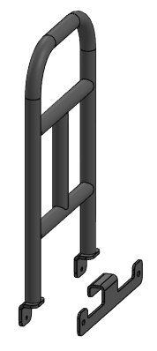
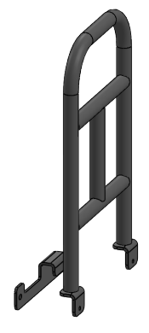

7. PATIENT BED DELIVERY AND INSTALLATION
7.1. Transfer
Considerations for a safe transfer;
- Make sure that no cables are connected during transport.
- Make sure that the power cable is wrapped around the hook on the bedside of the patient bed
- Make sure that the wheels are locked when loading and unloading
- Transport the bed on suitable ground.
- Check that the brakes are on during transportation.
- Remove accessories that may fall off during transportation.
Do not forget to unplug the power cord before transporting the patient bed.

7.2. Installation and Assembly
Adjust the bed as follows
- The following rules must be observed when installing the bed frame.
- Refer to the scope of delivery and bed variants.
- Attach the accessories accordingly.
- Make sure that the floor is suitable during the assembly process.
- Make sure that the connection cables are plugged into the correct sockets.
- Check the earthing cables.
- Deliver the dismantled packaging to the necessary places for environmental health.
Please follow the instructions in order to avoid limb entrapment during product folding.

NOTE: If any problems are encountered during the installation of the patient bed, the intervention should be carried out by NİTROCARE technical service personnel.
Caution Danger of injury
During assembly, install moving accessories last, as there is a risk of injury from falling.
When assembling the electrical system, check the cables for any deformation of the cables, as there is a risk of electric shock.
Ensure that the mains supply is disconnected during bed assembly Ensure that the castors are locked before assembly.
The patient bed should be assembled by technical service personnel or trained hospital staff.
8. TRANSPORTING THE PATIENT
8.1 Considerations for Patient Transportation
Make sure that the patient bed is in the appropriate position.
- Make sure that no cables are connected during transport.
- Make sure that the power cable is wrapped around the hook on the bedside of the patient bed
- Make sure that the wheels are locked when loading and unloading
- Transport the bed on suitable ground.
- Check that the brakes are on during transportation.
- Remove accessories that may fall off during movement.
- Make sure that the patient is in the center of the bed.
- Make sure that the side rails are up.
- Make sure the patient bed is at the lowest level.
9. OPERATION
9.1. Initial Start-up
Prepare the bed as follows;
- Check the electrical connection points (socket inputs) before plugging in the bed.
- Check the connections of the earthing cables.
- Check the insulation of the connection cables. Check for any deformation or crushing.
- Check the wheels and also check whether the brake system wheels are functioning.
- Plug the power cable into the socket for power supply. Make sure that the power is switched on.
- Switch on and check the back, foot, height and other function motors.
- Check the control system.
- Check the function of the side rails.
10. ELECTRICAL SYSTEM AND CONTROL ELEMENTS
10.1 Electrical System
The patient bed has a control box, foot motor, back motor, calf movement, height motor and hand control. As a working principle, the system consists of the control box receiving the data and performing the functions of the functions with the command process given from the hand control. Motors Below is the connection diagram of the system. Safety rules must be followed during connection. Please read the instructions carefully. Read the electrical information on the product label.
The components and structure of the NITROHB models are designed in accordance with safety rules.
The models have IPX4 / IPX6 degree of protection.

WARNING Electrical intervention should be carried out by authorised and trained personnel and support should be obtained from the manufacturer when necessary.
CAUTION: Do not touch the control box, motor and cables while the patient bed is in operation.
CAUTION: If the patient bed is connected to an off-grid power supply, check the periodic checks of the power supply and
refer to the instructions.
CAUTION: Electrical intervention must be carried out by trained personnel. Accidents due to electric shock may occur.
Dangers of injury when performing the movement function of the patient bed.

Make sure that there are no body parts between the patient bed platform. When adjusting the position of the patient bed, stay away from pinch points. Do not move the patient bed beyond the safe load.
Model-dependent control elements;
• Wheels

11. TECHNICAL DIMENSIONS
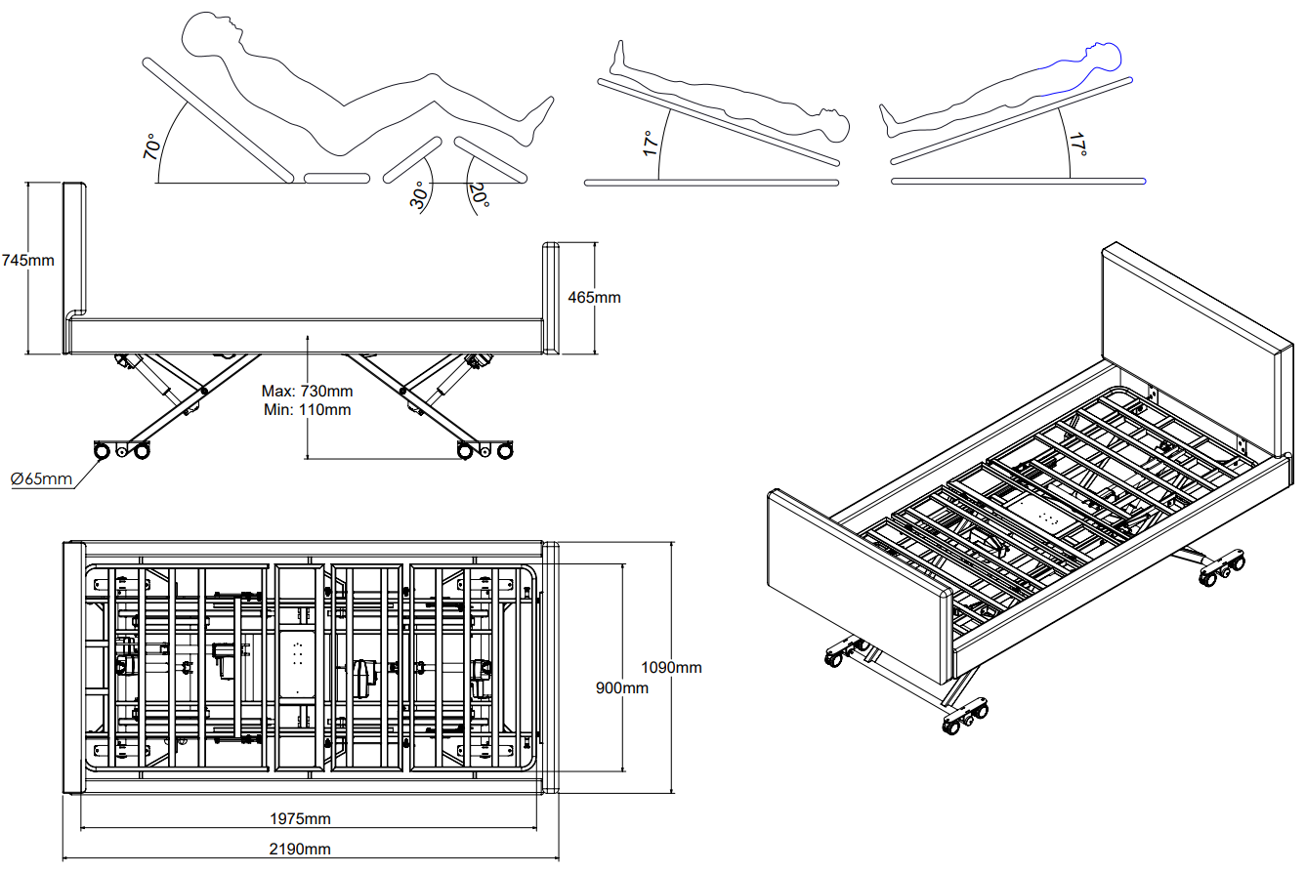
MIRANDA COMFORT 90 CM WIDTH

MIRANDA COMFORT 105 CM WIDTH
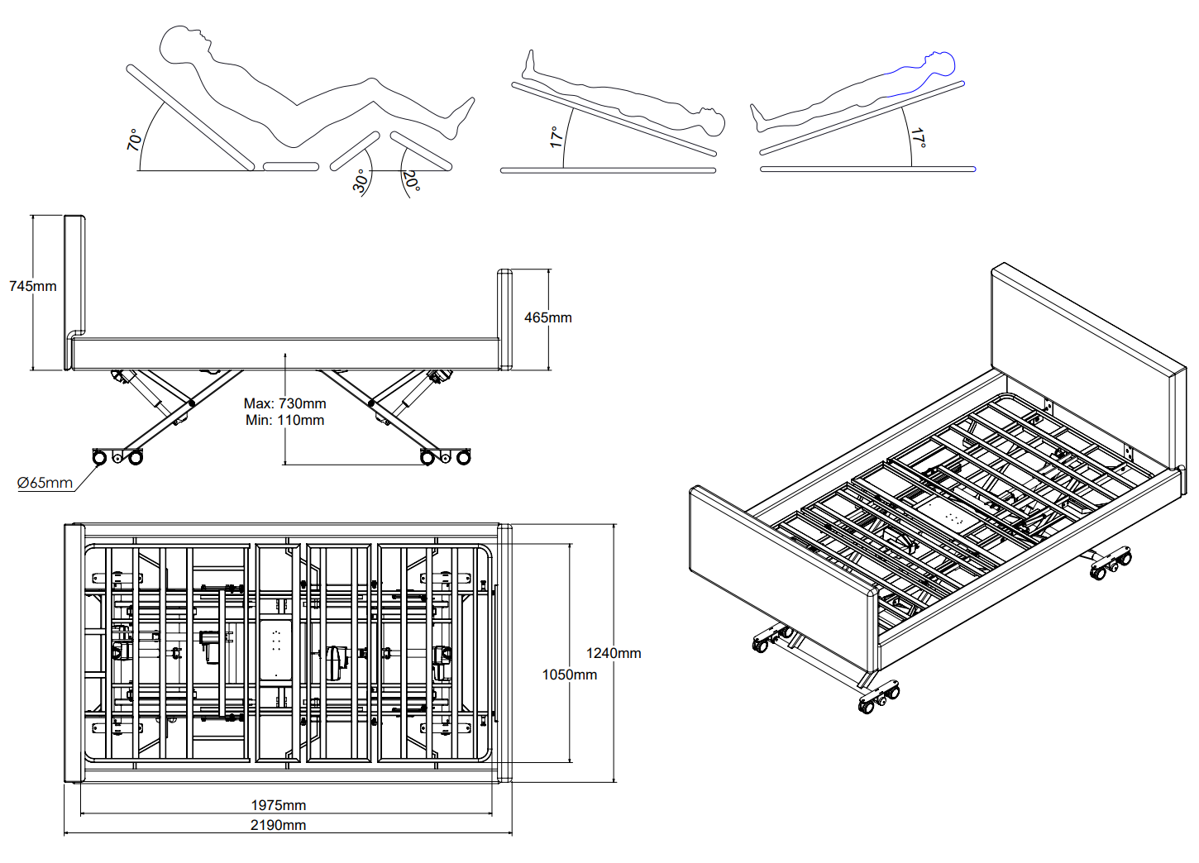

12. MAINTENANCE, REPAIR AND CLEANING INSTRUCTIONS
12. Maintenance and Repair Periods

Injury may occur due to incorrect maintenance.
The maintenance person should get support from the manufacturer company in matters he/she is not sure about.
Take necessary safety precautions before maintenance.
Do not use spare parts not recommended by the manufacturer.
Do not perform maintenance while the bed is in functional movement.
NOTE: maintenance records of patient beds should not be kept and these intervals should be made at certain times.
12.1 Monthly Maintenance
- Check the moving parts of the patient bed (back, height, trendelenburg movement, etc.).
- Check the joining elements (bolts, nuts, etc.).
- Check the accessory slots and see if there is any wear.
- Check the wheels and their functions.
- Check the brake system.
- Check the side railing movement functions.
12.2 Annual Maintenance
- Check the joints of the movement functions.
- Check the joints of the bed frame.
- Check the bolts and joints of the brake system.
- Check the functions of hydraulic parts and check for any leakage or leakage.
- Check the wheel function and check the wheel connection bolts.
- Check the side railing connection points and fasteners.

Failures caused by errors in use and spare parts demand are out of the scope of warranty.
Maintenance should be carried out by trained hospital personnel and if any problems are encountered, our company's technical service unit should be informed.
Check all bolts and tighten if necessary.
Replace worn accessories.
Do not replace worn materials with faulty materials.
CAUTION: Improper care may damage the patient bed.
If the hospital authorised personnel are not sure, seek advice from NITROCARE. Maintenance should only be carried out by authorised, trained personnel.
Spare parts requests and information.
13. Spare Parts
Failures caused by errors in use and spare parts demand are out of warranty.
Maintenance should be carried out by trained hospital staff, if any problems are encountered, our company's technical service unit should be informed.
Receiving spare parts requests and information
NITROCARE technical service
teknikservis@nitrocare.com.tr
0542 845 23 05
14. Cleaning / Disinfecting Instruction
14.1 Cleaning
- Use suitable detergents for cleaning. The VOC values of these detergents should be at appropriate values that will not harm the environment and human beings.
- Do not use abrasive powders, steel wool, steel wire brushes or abrasive sponges and cleaning agents that may damage the product surfaces.
- Do not use solvents and detergents that may affect the plastic structure and consistency (benzene, toluene, acetone, etc.).
- Clean the stainless steel areas of the product with a maintenance spray, the pH value of the cleaning spray should be: 10.2.
- The density value of the maintenance spray should be 0,855 g/cm³.
- It must be biodegradable.
- The cleaning spray must not contain AOX.
14.2. Disinfection
- The disinfectant Detrosept AF applied in the disinfection process must be a fast-acting alcohol-based spraying and wiping disinfection product that does not contain phenol and aldehyde.
- Disinfecting use is applied by spraying to completely cover the pre-cleaned medical device (spray distance 30 cm). For its effectiveness, it should be kept for the duration of microbiological activity and the product should be wiped by choosing a sterile, non-particulate cloth.
- Features of the disinfectant product;
Effective in 1 minute (bactericidal, fungicidal, virucidal, tuberculosidal)
Aldehyde and phenol free
Compatible with glass, ceramic, silicone, plastic (including plexiglass), wood, aluminium and stainless steel materials
Broad spectrum of action
10% ethyl alcohol, 20% propane 2-ol, 0,25% Didesylmethylpoly(oxyethyl) ammonium propionate, preservative additives, perfume deionised water
didecylmethylpoly (oxyethyl) ammonium propinate, protective
- Storage conditions of the disinfected product;
The expiry date should be 2 years from the date of production.
Keep the packaging tightly closed in a well-ventilated and well-ventilated environment between 0-25°.
Use disinfectant with its properties.
WARNING
Disinfectant is flammable. Keep away from sources of ignition. Irritant Avoid
contact with skin and mucous membranes. In case of contact with skin, rinse
with plenty of water.
15. TROUBLESHOOTING
PROBLEM | REASON | SOLUTION
THE BED DOES NOT RESPOND TO ANY COMMAND: | 1. The plug is not inserted into the socket  2. The power cable is not working.  3. Control box does not work.  4. Hand control does not work | 1. Insert the plug into the socket.  2. Replace the power cable.  3. Send the control box for repair  4. Send the hand control to service
ENGINE DOES NOT START WHEN THE SYSTEM IS RUNNING | 1. Engine defective  2. Hand Control Malfunction | 1. The motor needs to be replaced, call the service centre.  2. Send the hand control to service
THE ENGINE DOES NOT START WHEN THE SYSTEM IS RUNNING,  FROM THE CONTROL BOX ‘’ CLICK ‘’' IF THERE IS NO SOUND: | 1. Control box defective  2. The remote control is defective | 1. Control Box needs to be replaced, call service  2. The remote control needs to be replaced, call the service.
16. SAFE STORAGE OF THE PATIENT BED
To prevent damage to the patient bed during storage;
Wrap the Power cable around the cable hook on the patient bed.
Remove the patient bed accessories and position them horizontally on the bed properly.
Pack the patient bed in such a way that there are no moving parts due to involuntary shaking.
Keep the height of the patient bed to a minimum
Adjust the patient bed position so that it is level.
Switch the brakes to the off position.
Do not keep the bed under load during storage.
Wrap electrical systems with protective packaging materials.
17. ENVIRONMENT
17.1 Environmental Protection
NİTROCARE carries the idea of taking great steps in protecting the environment by considering future generations. The materials of this product are environmentally compatible. It does not contain hazardous substances. Attention should be paid to the symbols and signs as information is provided with the symbols and signs used. The product uses recycled steel, electrical components, packaging materials, plastics and wood materials.
The maximum acoustic noise level of the patient bed is 60 dB.
Defective electrical materials should be delivered to the manufacturer without being thrown away.
Deliver the packaging materials to the manufacturer or a licensed recycling company.
Deliver the defective plastic materials to the licensed recycling company or the manufacturer.
NOTE: For necessary information, support should be obtained from our after-sales service unit.


18. GUARANTEE
NITROCARE will only be held responsible for regular servicing and product reliability.
This product is covered by a 24-month warranty from the date of purchase. Defects caused by manufacturing and assembly defects are free of charge. Faults arising from usage errors are not covered by the warranty. Product use is determined within the framework of the terms and conditions determined by the standard.
19. CONTACT
NİTROCARE MEDICAL FURNITURE INDUSTRY AND TRADE ANONİM ŞİRKETİ
Şeyh Şamil Mah.OSB. 1st Cad. No:6/1 Sivas / Merkez TURKEY
Tel: 0346 218 19 10 Fax: 0346 218 19 14
E-mail: info@nitrocare.com
http:// www.nitrocare.com
After Sales Service Contact
Tel : 0542 845 23 05
Mail : teknikservis@nitrocare.com.tr
Fax : 0346 218 19 14

