2 MOTORS PATIENT BED
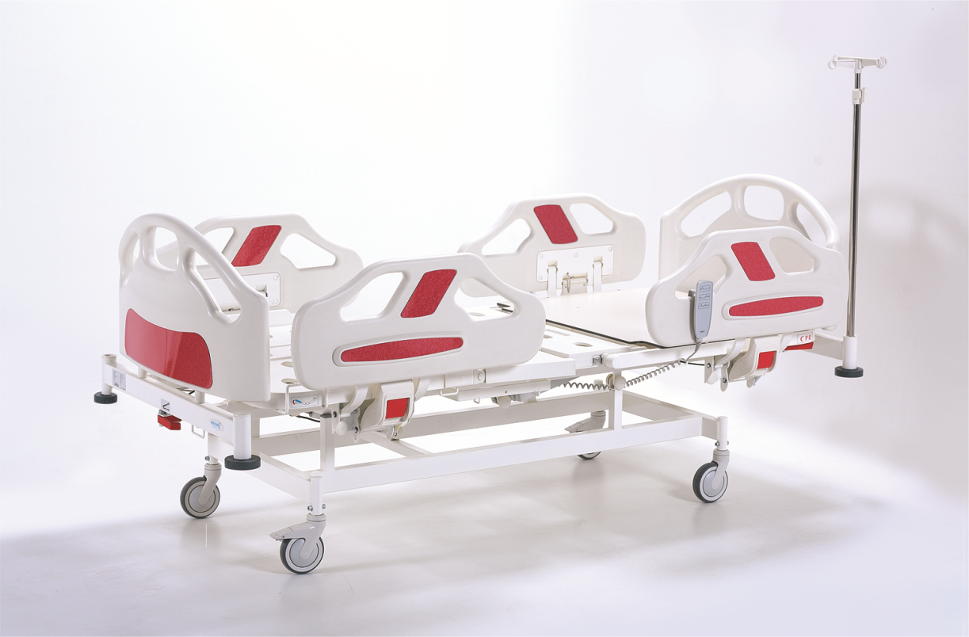
FİESTA
2220

Nitrocare
Positionable Patient Bed



Positionable Patient Bed

A) MANUFACTURER COMPANY : Gökler Mobilya Medikal ve Sağlık Hizmetleri A.Ş.
B) BRAND : NITROCARE
C) ADRES : Organize Sanayi Bölgesi 1. cad. No:7 Merkez / SİVAS
D) TEL NO : 0 346 218 19 10-13
E) FAX : 0 346 218 19 14
F) E-MAİL : info@nitrocare.com.tr
G) TYP : Hospital furnishings and equipment for medical purposes
H) MODEL : NITRO HB 2220
I) USEAGE LIFE : 10 Years
J) SERVICE STATION : Gökler Furniture Medical and Health Services Inc.

NITRO HB models are designed essentially with maximum safety and mobility. They are designed considering the physically disability and comfort for the highly risked patients. This user manual must be read clearly through to avoid customer related damages and to achieve the best performance of the product.

1 Symbols 5
1.1 Warnings 5
1.2 Other Symbols 5
1.3 Symbols and Labels on the Product 6
1.3.1 Labels based on Control Devices and Performances 7
2 Security and Dangers 8
2.1 Security Instructions 8
2.2 Terms of Use 9
3 Standards and Regulations 10
4 Functions 11
4.1 Usage 11
4.2 Usage Error 11
5 Scope of Delivery of Patient Beds 12
5.1 Scope of Delivery 12
5.2 Bed Alternatives 12
6 Installation 13
6.1 Delivery 13
6.2 Carrying 13
7 Mounting 14
8 Operating 15
8.1 First Operating 15
8.2 Battery Operating 15
8.3 Take out of the Patient Bed from the Hospital Service 16
8.3.1 Battery Deactivating 16
9 Control Elements 17
9.1 Functions 17
9.2 Nurse Control Panel Functions 18
9.3 Hand Control Unit 19
10 Systems with Manual Control 20
10.1 Leg Rest Adjustment Mechanism 20
10.2 CRP Handle 20
10.3 Side Rails 21
10.4 Head and Foot Boards 22
10.3 Side Rails 21
10.4 Head and Foot Boards 22
10.5 Central Brake System 22
10.6 IV Pole Stand 23
10.7 X-Ray Cassette Holder 23
10.8 Multipurpose Storage Drawer 24
10.9 Protractor 24
11 Patient Carrying 24
11.1 Points to Consider by Patient Carrying 24
12 Cleaning / Disinfection 25
12.1 Periodical Cleaning 26
13 Problem Solving 27
14 Maintenance and Repair 28
14.1 Maintenance Periods 28
14.2 Spare Part 29
14.3 Accessory 30
15 Safety Controls 31
16 Disposal 32
16.1 Environment Protection 32
17 Warranty 32
18 EC Declaration of Conformity 33
19 Technical Details 34
19.1 Accuracy of Displayed Values 34
19.2 Mechanical Specifications 34
19.3 Electrical Specifications 35
20 Storage 36
21 Product Delivery 36
22 Service and Maintenance Diary 37

1. Symbols
1.1 Warnings
1.1.1 Warning Types

Recognize the kind of danger by using the symbols below in warning announcements.
- Warning, it shows property potential damage.
- Warning to personal injury risks.
- Warning to danger potential fatal injuries.

1.1.2 Warning Structure

Danger type and source:

- Danger precautionary warnings

1.2 Other Symbols
1.2.1 Instructions
Instruction Forms
Follow the instructions listed below if it is required.

1.3 Symbols and Labels on the Products

 | B Type safety due to electricity accidents
 | CE Symbol
 | Accompanying Documents
 | Read user manual
 | Safe carrying weight
 | Maximum weight of the patient
 | Grounding
 | Suitable to indoor use
 | Patient bed is cleanable with moist cleaning rag
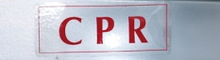 | CPR label
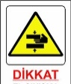 | Jammer danger
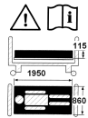 | Bed dimensional occurring danger, Read the user manual, Side rail operating danger and warning symbols
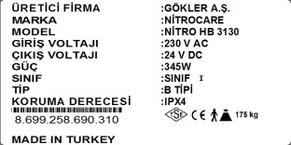 | Product label

1.2.1 Labels based on Control Devices and Performances

Back rest adjustment (down)
Back rest adjustment (up)
Leg rest adjustment (down)
Leg rest adjustment (up)
Trendelenburg

2. Security and Dangers
2.1 Security Instructions

- Please follow the instructions clearly and place a copy of the instructions near to the bed if it is required.
- Use the right power supply for the bed
- Please be sure that a qualified staff operates the bed
- Spare parts can be changed only with the original one. It must be changed from qualified staff.
- Please do not load to many weight on beds
- Please do not use the bed when you notice that the functions do not work and inform the technical department.
- Pass information to the patient and other users regarding the functions.
- Do not exceed safe carrying capacity. In case of exceeding this capacity, lower the height of the bed to the lowest position in horizontal straight form and do not use the functions of the bed.
- A second person is not allowed to sit on the bed while a patient is laying on it.
- Patient bed shall not be used from more than one person at the same time.

- Please control the safety of the floor and the environment of the bed before adjusting the position if.
- Plug out the power cable before cleaning the bed or before changing any parts of it.
- Patient and the nurse are in danger at the situations listed below.
- When the power cable is damaged.
- When the floor and the ambiance around the bed is not save while transporting the bed from one place to another.
- By wrong cleaning ,( example; automatic cleaning or cleaning with pressure water)
- When the safe weight capacity is exceeded.
- Only spare parts from the authorized service can be used. Manufacturer cannot be held responsible for any damage, loss or injury by using separate parts from other suppliers.
- Cleaning must be done with room temperature water and disinfect solution with a moist cleaning rag.
2.2 TERMS OF USE
Terms of use of Patient Bed must be followed

- Temperature range must be between +10 ° C and 40 ° C
- Bound moisture is between 30 % and 75 %
- Beds are designed for use of medical purpose for rooms. Electrical installations must therefore suit with the local connection.
- Conditions listed below must be followed.
- Do not stow something on the plastic bottom chassis
- Back leaning section : 0-70⁰
- Calf aspect : 0-15⁰
- Leg aspect : 0-35⁰
- Trendelenburg : 15,5⁰

- Do not connect the patient bed with another free mechanism.
- Only the technical service is allowed to treat in any breakdown situation.

3. Standards and Regulations

Patient bed suits to the standards and directives listed below.
TS EN 60601-2-52 : 2011
TS EN 60601-1 : 2011
TS EN ISO 14971: 2013
93/42/EEC
90/384/EEC

Application of quality management system is listed below.
ISO 9001: 2000
ISO 1400: 2004
TS EN 13485: 2003
TS EN 17025: 2014

4. FUNCTIONS
4.1 Usage
Patient beds are designed for patient care in hospitals and for treatment of adults.
Patient beds must be controlled from qualified and trained staff.

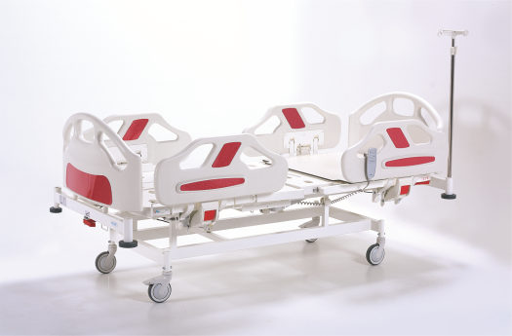
Patient bed should be used by qualified and trained staff in treatmant hospitals

4.2 Usage Error

Patient beds are not applicable for children and babies.
- Do not use the bed without supervision of qualified staff
P.S.: Do not use the bed except the usage mentioned above. For required information contact NITROCARE.
5. Scope of Delivery of Patient Beds
5.1 Scope of Delivery
Delivery:
- Please control the products by receiving the delivery if they are delivered exactly to the packing slip.
- By noticing some defects or losses of the product during the unloading, please inform the technical service in written form.
- Please test all mechanical and electronic functions and be sure that all motors and all control buttons are working as required.

5.2 Bed Alternatives
S= Standard
I= Optional
OPTIONS
22 DANSITY MATRESS
32 DANSITY MATRESS
VISCO MATTRESS
MECHANICAL TRENDELENBURG
NURSE LOCK
BED EXTENSION
BACREST X-RAY
FULL HPL BED SURFACE
BATTARY
HAND GRIPS

6.1 Delivery
Points to consider for safe transportation
- Be sure that no cables are connected while transport
- Be sure that the electrical cable is connected to the hook which is placed at the head of the patient bed
- Be sure that the castors are locked while loading and unloading
- Carry all beds on proper floors

6.2 Carrying
Do the adjustment listed below
- Follow the rules listed below during the installation of the beds
- Lock at the scope of the delivery and bed alternatives
- Assemble all accessories to their right slots
- Assemble the foot and head boards while delivery
- Be sure that the floors are suitable for mounting

7. Mounting

Working at a bed with wounding risks
Be sure that the patient bed is plugged out while mounting
Be sure that the castors are locked before mounting

Montaj öncesinde tekerlerin kilitli olduğundan emin olun

Wrong mounting of the patient bed can injure Mounting of the patient bed must be don from the technical service or from a trained hospital staff.

10 11
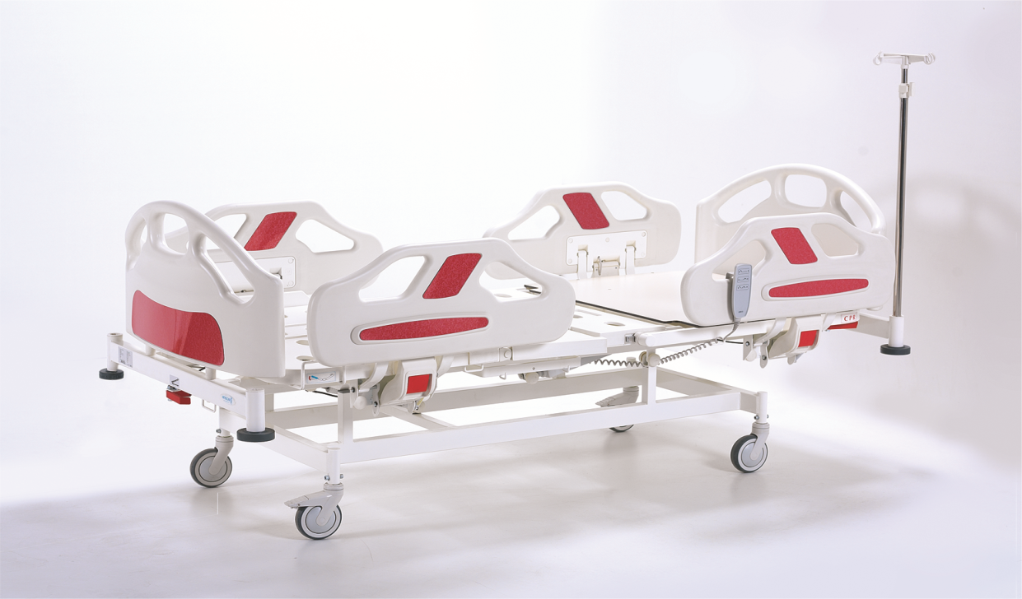
6
2
9
7
8
1
5
4
3

NİTROCARE Patient bed general specifications

1. Headside Panel 8.Trendelenburg Handcraft
2. Mechanical CPR 9. Footside Panel
3. 125mm Castors 10. Side Rails
4. Hand Control Panel 11. IV Pole
5. Side Rails opening closing (lock)
6. Central brake system
7. Plastic Protection Bumpers

8. Operating
8.1 First Operating
Prepare the bed as listed below;
- Plug in the bed
- Adjust the bed to the highest position and try literal movements
- Adjust the bed to the lowest position and try literal movements
- Control the castors and the brake system if they are working well.
- Try fowler and vascular positions and control if the motors are working well.
- Control the control panel and lock panel.
- Control the functions of the side rails.
- Send the removed packing to the essential places for environmental health.

P.S: If some problems occur by assembling, please contact the NITROCARE technical service and let them interfere to the problem.
8.2 Battery operating
Patient beds are delivered with battery. Battery is for further working process when power is cut and when any adjustment is require while transport of the bed.
Battery charging: ( Options )
- Battery is charging when power cable is plugged in.

Battery mounting
Battery changement must be done from qualified and trained staff.

To optimize the battery performance:
- By power cut and by patient transport, plug out the power cable for a short time.

In case of heat at the battery place

- Plug out the cable of the patient bed.
- Contact NITROCARE technical service.
8.3 Take out of the patient bed from the hospital service
Patient bed must be taken out as listed below.
- Plug out the cable of the patient bed.
- Deactivate the battery
- Take out the accessories

8.3.1 Battery deactivating
Make provision to not damage the environment of the patient bed while storing
- Deactivate the battery
To deactivate the battery:
- Brake the power connection of the patient bed

9. Control Elements
9.1 Functions
Wounding risks by adjusting the patient bed
Be careful to not jam in the body of the patient between the bad platform and back rest.
Stand apart from the adjusting parts of the patient bed by adjusting the positions.
Do not move the patient bed by passed safe carrying capacity.



Control elements connected at the model
- Control Panel (To adjust the position of the patient)
- Control Panel with LED (To adjust the position of the patient)
- Nurse Control Panel ( To adjust the position of the patient)
- Nurse Control Lock
All positions are out of use by locking the nurse control lock.
When the patient bed do not function by individual position adjustments
- Control if the nurse control panel locks are open, all lighted buttons are locked

9.2 Nurse control panel functions
Nurse control panel has a specification of controlling and activating/ deactivating the functions of the patient bed besides the patient control panel.

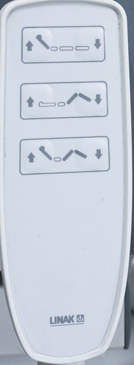
6
4
2
1
5
3

1. Provides upward movement of the back function
2. Allows the back function to move down
3. Provides upward movement of the foot function
4. Provides the down movement of the foot function
5. Provides full upward movement of the bed
6. Allows the bed to move down entirely

P.S: In emergency situations where a upside-down or exact opposite position of the patient is required, back rest, leg rest, height and trendelenburg adjustment can be done with the help of the motor system.

10. System with Manuel Control
10.1. Trendelenburg Tuning Mechanism
The trendelenburg movement of the patient's crib is provided by pulling up the Trendelenburg adjustment mechanism.

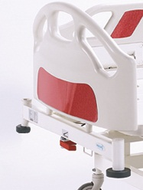

10.2 CPR Handle

Patient can be injured from the fast back rest adjustment.
Be careful to not jam in the body of the patient between the bad platform and back rest.
Be sure that the side rails are at the lowest position.
Do not move the patient bed by passed safe carrying capacity

CPR handle adjusts the bed backrest in flat position in emergency situations.

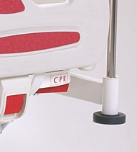

CPR handle (hold the handle pulled and push the back rest slowly down)

10.3 Side Rails
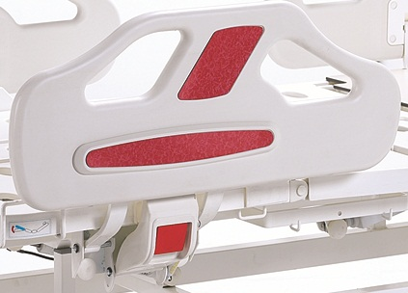

FOR FIESTA MODEL; The download is done by pulling out the red colored bracelet on the bottom of the scare. The lift is done by pushing up the fear.
There are 4 banisters for the safety of the patients in Patient Beds. It ensures that the lying patient is fallen from the hospital and protected from external factors. The safe load carrying capacity of fear is 75kg per arm.

P.S: Do not pass the indicated standard weight capacity of the side rails. (max. weight 75 kg)

10.4 Head and Foot Boards

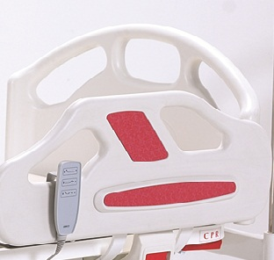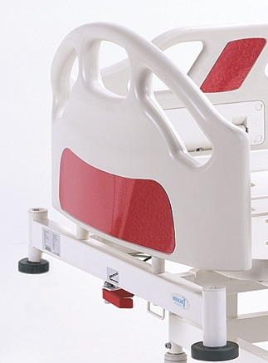

These accessories are designed to protect the patients from exterior facilities and to provide for their comfort. These boards are easily removable. To remove the boards, pull only the upper part up. To fix the boards, set the legs, at the board end to the adjusting sleeve and push it slowly down.

10.5 Linear Brake System

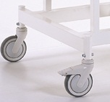
There are 2 cranes mounted on the Patient Bed. The braking system is provided by the action of the brake mechanism located on the top of the wheel.
11. Patient Carrying
11.1 Points to Consider by Patient Carrying
Be careful that the patient bed is at a suitable position.
- Brake systems must be closed while laying the patient.
- Be sure that the patient is laying in the middle of the bed.
- The side rails must be in the up/ closed position.
- The height of the patient bed must be at the lowest position

12. Cleaning / Disinfection
Accidentaly wounding risk
Plug out the power cable before cleaning the bed.
Lock the adjustment functions before cleaning the adjustable parts of the patient bed.

Wrong cleaning/disinfection which can damage the bed
Do not use pressure cleaner. Do never use for cleaning acid, solver, detergent, phosphate or phosphate consisting or corrosive products (8 - optimum pH between 6).

P.S: Headboard plastics, handle plastics and other plastics used at the patient bed are made of antibacterial plastics (ABS). Metal surfaces are covered with electrostatic powder coating. All NITRO HB models are therefore easy cleanable. Patient beds can be cleaned with moist cleaning rags or sponges. Important matter by cleaning is to clean the total surface and the control panels of the patient bed after the release of the patient.

For safety and healthy cleaning
- Plug out the power cable of the patient bed.
- Use a suitable detergent for cleaning.
- Do not use abrasive powders, steel wool or other harming materials and cleaning materials.
- Do not use solver and detergents which can affect the plastic structure and stability (benzene, toluene, acetone aso.)
- Clean the bed with a proper squeezed moist cleaning rag.
- Do not clean the electrical parts.

12.1 Periodical Cleaning
12.1.1 Daily Cleaning
Clean the bed parts listed below
- All control panels
- All side rails/ handles
- CRP handle
- Bed surface and head/foot boards
- Accessories and rails

12.1.2 Cleaning before patient changing
Clean the bed parts listed below

- All control panels
- All side rails/ handles
- CRP handle
- Easy accessible bed surface
- Mattress platform surface
- Easy accessible metal surface
- Cables
- Side Rails
- Bumpers
- Brakes
- Castors
- All accessories
- Lifts

13. Problem Solving
Problem | Reason | Solution
Bed do not follow any commands : | - Is the connector plugged in.  - Electrical cable does not work.  - Control case does not work | - Plug the connector in.  - Change the electrical cable.  - Send the control case to service.
When the motors do not work while the system is on or,  A ‘click’ noise comes out of the control case: | - The socket connection between the motor and the control case is not connected.  - Motor is broken  - Control case is broken | - Control that the socket connection between the motor and the control case is connected.  - Call the service to change the motor.  - Call the service to change the control case.
When the motors do not work while the system is on or,  A ‘click’ noise does not come out of the control case: | - Control case is broken  - Control panel is broken | - Call the service to change the control case.  - Call the service to change the control panel.
When the battery is empty and a ‘click’ noise is not to hear: | - Battery is totally empty  - Battery has a defect | - Load the battery.  - Change the battery.
When the motors does not work while the system is plugged in: | Battery is totally empty. | Load the battery. If this do not solve the problem call the service.

System does not work | System requires a reset. | Press at the back rest up and down adjustment buttons at the same time and wait till the kick sound starts and stops. When the sound stops, system will be again active.

Power failure
When you are confronted with a power failure, please let only the authorized person solving this problem.

14. Maintenance and Repair
14.1 Maintenance Periods
Accidentaly wounding risk
Plug out the power cable before cleaning the bed.
Lock the brakes while mounting and maintenance.

Defective beds can have wounding risks
Defective beds must be immediately repaired. It is strictly forbidden to use defective beds.

Patient bad can injure because of wrong maintenance.
Please get help from NITROCARE when the authorized person is not sure about the handlings.
Maintenance shall only be made from authorized and trained person.

P.S: A registration must be held for maintenance of each patient bed and it must be done periodically.

14.1.1 Monthly Maintenance
Control all movable parts for corrosion.

14.1.2 Maintenance in every 4 months
Control the handle of the brake function.
Do the function controls from the lifts.
Control the screws and hinges of the patient bed.
Control the movable mechanism of the patient bed.
Control the screws on the castors and if required tighten the screws.
Control the movement and the reliability of the side rails.

14.1.3 Maintenance in every 12 months
General controls of the mechanical movement systems and plastic accessories of the patient bed must be done. All wearing parts and loosening parts must be changed after this procedure.

14.2 Spare Part
- Spare parts demand regarding wrong use is not covered by the guarantee.
- Maintenance shall only be made from authorized and trained person. Inform the technical service from NITROCARE by any problems.

Spare part and information demands
- NITROCARE technical service
- teknikservis@nitrocare.com.tr
- 0542 845 23 05

14.2.1 Corrosion
- Control the screws on the castors and if required tighten the screws.
- Control all lock mechanisms.
- Change all worn accessories.
- Do not use wrong parts after changing wearing accessories.

14.2.2 Functionality
- Control the position adjustment of the patient beds that they are functioning with maximum efficiency.
- Change all worn parts.

14.2.3 Motors
- Control the motor adjustments.
- Control the wrong and broken adjustments. Change the faulty motor if necessary.
- Control the motor caps, change the caps if they are worn.

14.2.4 Battery
- Control that the battery is working properly. (Plug out the power cable of the patient bed)
- Change the battery in required circumstances.

14.2.5 Fuses
Changing and controls of the fuses must be done from experienced and trained personal.
Fuses can only be changed from the manufacturer. (LINAK)

Castors
- Clean the castors completely.
- Control the connection screws and change it if necessary.
- Move the castors and control that they are functioning properly.
- Forwards and backwards movement.
- Limitless movement.
- Control the brake system and change it if necessary.

14.3 Accessories
- Control the accessories and be sure that they are functioning properly and change it if necessary.

15. Safety Controls
Wrong safety controls can have wounding risks.
Safety providing will be done from our technical servis of our factory. Safety controls will be noted in the product delivery, technical service and after sales service form.


Defective bed can have wounding risks.
Defective beds must be immediately repaired.

Do not continue using beds with big damage.

P.S: Patient beds are manufactured suitable to TS EN 16601-2-52 / TS EN ISO 14971 standards. All required tests and examination controls are done under supervision of TSE auditors. This will be reported to maintain the quality of the products.

16. Disposal
16.1 Environment Protection
NITROCARE cares about the environmental protection for the posterity and makes great strides in this opinion.
Materials of this product have environmental compatibility. It does not contain dangerous substances.
Customer will be informed with the used symbols and signs.
Recycling steel, electrical components and wooden parts are used in the manufacturing.
Products are packed with recyclable boxes.



17. Warranty

NITROCARE can only be held responsible for its regularly service and product reliability.
When a critical irreparable problem rises while maintenance
Stop using the patient bed.
This product has a warranty period of 24 months from the date of purchasing. Defects arising from manufacturing and installation will be repaired free of charge. Defects arising from wrong use are not covered by the guarantee. Product using terms and conditions are indicated from standards.

18. EC Declaration of Conformity

19. Technical Details
19.1 Accuracy of Displayed Values

- Weight (integrated scales)
0.5 kg
- Angle of inclination
± 3 ͦ

NITRO HB 2220 Two motors patient bed Technical Specs
 |  |  | Dimension | Unit
A | Bed Length (Overall) |  | 2230 | mm
B | Laying Surface Length |  | 1950 | mm
C | Laying Surface Ground Clearance | min. | 505 | mm
C | Laying Surface Ground Clearance | max. | 505 | mm
D | Bed Width Overall |  | 1085 | mm
E | Laying Surface Width |  | 860 | mm
F | Bottom Chassis Width |  | 40 x 60 x 2 | mm
G | IV Pole Stand Hight | min. | 1240 | mm
G | IV Pole Stand Hight | max. | 1600 | mm
α | Back rest Angle |  | 0-70 | °
β | Knee angle |  | 0-35 | °
θ | Leg Rest Angle |  | 0-15 | °
 | Trendelenburg Angle ( Optional ) |  | 15,5 | °
 | Castor Diameter |  | Ø125 | mm
 | Safe Carrying Capacity |  | 250 | Kg
 | Mattress |  | 855x2100x120
S | Iv pole

19.3 Electrical Details
Parts and construction of NITRO HB models are designed pursuant to general safety rules.
These models have IPX4 degree of protection
Device Specification
 |  | Manufacturer |  | GÖKLER A.Ş.
 |  | Brand |  | NITROCARE
 |  | Input Voltage |  | 230v
 |  | Voltage Tolerance |  | ±10%
 |  | Frequency |  | 50 Hz
 |  | Power |  | 340 VA
 |  | Output Voltage |  | 24 V Permanent
 |  | Class |  | 1
 |  | Type |  | B
 |  | Protection Degree |  | IPXX,
 |  | Back Rest Adjustment Motor | Leg Rest Adjustment Motor
Manufacturer |  | LINAK | LINAK
IP |  | X4 | X4
Components |  | Manufacturer / Brand |  | Technical Details
MOTOR 1 |  | LINAK |  | 24V, IP54, 3500 N
MOTOR 2 |  | LINAK |  | 24V, IP54, 3500 N
Control Case |  | LINAK |  | 230 V, 50Hz
20. Storage
To store beds long time, the instructions listed below must be followed
  - Reset all settings of the bed
  - Please be sure that the castors are set on a smooth floor.
  - Please do not stow another bed on it or another heavy product

21. Product Delivery

Order number :

Client :

Model number :

Serial number :

Delivery Date :

Delivered From :

Confirm form the hospital personal that the delivered patient bed is working properly.
Date :

Seal and Signature from the Client :

Seal and Signature from the Carrier :

22. Service and Maintenance Diary
Service Explanation | Date | Operated From

Contact:
Address: Organize Sanayi Bölgesi 1. Kısım 1.cad NO:7 SİVAS/Turkey
Telephone: 0346 218 19 10
Fax :0346 218 19 14
E-Mail : info@nitrocare.com
Website: http:// www.nitrocare.com

